# Table of Contents

Contents 1

Analysis 1

Problem specification 1

Stakeholders 1

Identifying the Target Market Group 1

Users 1

Accessibility for different users 2

My sample of the TMG 2

Why is it suited to a computational solutions 2

Computational thinking methods used in my game: 2

Decomposition 2

Abstraction 3

Research and identification of solutions to the problem 3

Platforms for designs 3

Research on python game libraries 4

Looking at other solutions 4

Stick fight: 4

Frog Smashers: 5

Brawhalla: 5

Interview with stakeholders 6

Bullets in other games 7

Gathering data 7

Conclusions 12

Features of proposed solution 12

Limitations of proposed solution 12

Objectives 13

System Requirements 13

Hardware Requirements 13

Software Requirements 14

Success criteria 15

Criteria 15

How to evidence 15

Design 16

Flow Diagram 16

The Basic Mechanics 17

Menu screen design 17

Settings Menu Design 18

Feedback from stakeholders 19

Creating the Settings Menu 19

File Structure 20

First Iteration 20

Second Iteration 20

Connecting interface devices 20

Data structures of my program 20

Classes that inherit pygame.sprite.Sprite 21

Other classes 21

First Iteration 21

Second Iteration 22

Algorithms 22

Main loop 23

Destructible Enviroment 23

Player movement 24

First Iteration 24

Second Iteration 25

Player collisions 27

First Iteration 27

Second Iteration 28

Finding the direction the player is aiming 28

Keyboard 28

Controller 29

Displaying the direction the player is aiming 30

Shooting 30

Loading in the next level 31

Spawning players 31

Permanent Storage 32

Method of distribution 32

Deciding between aggregation and composition 32

Local and global variables 32

Validation 32

Keyboard buttons and Controller inputs 33

Reducing the effects of stick drift in my game 33

Sliders 33

Toggle switches 33

Type of Development 33

Testing 34

Inputs and Outputs 34

Development 35

Stage 1 - Displaying the levels 35

Creating a basic game loop: 35

Displaying a level 36

Stage 1 evaluation 39

Stage 2 - Storing levels in txt files 39

Stage 2 evaluation 40

Stage 3 - Creating the Player 40

Gravity 41

Stage 3 evaluation 43

Stage 4 - weapons 43

Weapon class 43

Weapon spawners 44

Players Interaction with weapons 44

Ammunition with weapons 45

Shooting 45

Stage 4 Evaluation 46

Stage 5, Changing the structure 46

Stage 5 evaluation 48

Stage 6 - Splitting game into multiple parts 49

Stage 6 Evaluation 49

Stage 7, Animations 50

Changing the direction that the player is facing 50

Player animations 50

Stage 7 Evaluation 53

Stage 8 – Improving the player movement 53

Stage 8 evaluation 54

Stage 9 - Basic Destruction 54

Stage 9 Evaluation 55

Stage 10 – Stakeholder/Beta Testing 56

Do you think the game is a has fun game mechanics: 56

Do you think the game has good visuals: 56

Do you think the game would make a good party game: 56

Have you got any ideas on what could be done to improve the program: 56

Review: 56

Evaluation 57

Post Development Testing 57

Criteria met 57

Criteria 57

Met? 57

Limitations 58

How to avoid these limitations 58

Maintainence 58

Final Code 59

main.py 59

game.py 60

player.py 65

level.py 70

tile.py 70

spawners.py 71

bullet.py 72

weapon.py 72

weapons.py 73

constants.py 73

dependencies.py 73

Bibliography 74

# Analysis

## Problem specification

There was a request from a group of college students for a recreational game to play after college together. The game development criteria ought to include a short learning curve and have a local multiplayer dimension. The game should also be non-competitive so that all players e njoy the game and so that some players who are less skilled win rounds as well as the highly skilled players. This criteria will ensure that players gain the greatest amount of satisfaction overall. Furthermore, I have set out to include destruction of the environment as part of the games core mechanics.

## Stakeholders

### Identifying the Target Market Group (TMG)

It is the interntion to make a game that will not contain gore but will contain cartoon violence. For this reason, the game will likely get a PEGI 7 rating which is the same rating that stick fight (one of the games researched) was given. This means that the target audience of the game will aim towards children which increases my TMG. The main group to benefit will be people under 25 e.g. young adults and children. This is beneficial as a large amount of young people regularly play games (in the uk 78% of 16-24 year olds play video games [source: [statista](https://www.statista.com/statistics/300513/gaming-by-demographic-group-uk/#statisticContainer)]).

### Users

The main group to benefit from the game are going to be the players. The main aim of the game will be for entertainment, interactivity with other players and group /individual enjoyment. Players will be a diverse group of users. They will likely already have some experience of how games work. This means an in-depth tutorial on user controls will not be necessary. However, controls for the game should be similar to other games the users have played as this will avoid a long learning curve for the player, minimises the amount of players that give up on the game early on and therefore, maximises the time for enjoying the game. This is especially important if the game is sold on Steam. Steam has a two hour window for gameplay refund policy. A screen should be shown when the player first opens the game which describes what the controls are briefly. Controls should be easy to change, and sensitivity should be easy to change.

### Accessibility for different users

The game should be usable with many types of controllers including those for people with disabilities. It should also have support for mouse and keyboard as not all players will have access to a controller. Options to change colours to make use of the game for colour blind users should be implemented and differences between colours should not be the only difference between two items e.g. different guns should have different shapes and different colours.

Users who do not speak English should be considered, so easy methods of choosing language should be implemented even if different languages are not added at the time. This addition will make further improvements to the game easier in the future.

### TMG Sample

The sample of the TMG is some of the students within my computer science class. They are familiar with computer games. In particular, interviews will take place with George Fox and Matthew Stead throughout the project. A larger sample group will be used for a survey form.

## Why is it suited to a computational solutions?

The problem is well suited for a computational solution for multiple reasons:

* The solution makes use of computer visuals that need to be rendered on a computer.
* Controllers are the one of the ways that I want to control the game.
* Controllers are an input method that can only be used with a computer.
* The option for the game would not use a computer would be a game with paintball guns in room. This would require players to have paintball guns and a room which would make the solution far more costly.
* There is no solution that would work without a computer.

## Computational thinking methods used in my game:

### Decomposition

The problem can be split into multiple smaller problems that can all be solved with small functions. Here are the smaller problems:

1. Taking inputs from the player
2. Moving the players
3. Checking for collisions
4. Moving bullets

Once each of these problems is done a frame is completed and the game can move onto the next frame. This repeats until the player closes the game. By decomposing the problem, the developer can save time and more easily develop the program.

### Abstraction

Abstraction can be used to represent complex objects and mechanics in my game. An example of this is how weapons and players will be represented by rectangular sprites. Mechanics such as jumping which involve contractions of muscles in a coordinated mechanism can be represented as the players y velocity increasing. By abstracting these elements, we reduce the complexity of the program which saves on the time for development. This means we can concentrate on curating the players experience. It also decreases the amount of computation by reducing the amount of clock cycles and memory usage.

## Research and identification of solutions to the problem

### Platforms for designs

Two languages have been considered as options for languages to develop the software, as well as two game engines, and there respective advantages and disadvantages as below:

* C++
* C++ - The benefits of C++ are that it is compiled, fast and a standard for game development, however my knowledge of C++ is not as good as in python and getting help is harder as the language is not taught in my college. Also the libraries for C++ game development are are more difficult to use than those for other languages.
* Python - Python is slower but it is the language that my college uses which means help is easier to find. Also I have more experience in python.
* Godot script - Godot is game engine that I could use to develop my game. It is open source and fast however lots of the complexity in the programming is taken away when developing in a full game engine. Also there is less flexibility for me as the developer to implement features that I want.
* Unity and C# - Unity is another game engine that I considered developing my game in. It is similar to godot but is not open source. The game engine is very popular which means that it easier to develop in as there is more documentation on its features. Also Unity has a few more features than Godot. The main problem with unity is its hostility towards developers. Unity has in the past year imposed fees on users for the download of their games by customers. For this reason I will not be using Unity.

Also the libraries for c++ are more difficult to use.

Overall I decided on using python for for the ease of use, the integration with college and my large amount of experience with the language.

### Research on python game libraries

The website Geekflare was used [(link here)](https://geekflare.com/python-game-development-libraries-frameworks/) to research the best python library to use for game development.

It was decided that Pygame was the most appropriate library for the game as it will make the development process far quicker since there is no need to spend time handling displays and events. Also, Pygame is the best option due to the amount of documentation on the python module and the volume of information on the internet, most notabky on YouTube. It is also a fast option compared to other python modules for game development. There are also two options with Pygame: either Pygame-ce can be used or I can use the official Pygame. The official Pygame is currently not in development and the owner of the GitHub repository will not let progress continue due to political reasons. Pygame-ce is currently a much more active project. For this reason, Pygame-ce was selected as best serving.

### Looking at other solutions

As part of the background research, there were three games played which were similar to the game that I set out to develop. Prior experience with these games helped identify the main positives and negatives of each program and decide on what features would best fit the game the best.

### Stick Fight:

Positives:

* Fast paced
* Easy local multiplayer
* Contains destruction of platforms

Negatives:

* Not open source, therefore users do not know what the application is doing with their data.
* Costs money which can act as a barrier to entry as some users cannot play the game as they cannot afford the game.
* Online multiplayer can have a problem with bugs as the servers are hosted locally on the players computers (teleporting through walls, extreme latency issues, etc.) because the servers are hosted locally on the players computers.
* It can be difficult for controller players to accurately aim as do not have reliable indicator of the direction that they aim. This can cause a disparity of

### Frog Smashers:

Positives:

* Fast paced
* Simple
* Open source

Negatives:

* Only controllers can be used. This limits the users as some users may not have a controller or may have only one controller which means they cannot play with friends.
* Very simple game mechanics which can do have variety in the ways they can be used but can get monotonous / boring.
* Uses unity which at first helps with lots of the programming would not show my skills in programming.

### Brawhalla:

Positives:

* Fast paced
* Many game mechanics which creates large amounts of complexity and combos
* Has a large number of active players reducing queue times for online play
* Various game modes which increases re-playability of the game

Negatives:

* The game is highly competitive which can create barriers to entry for new players
* The lack of randomness in gameplay can reduce the chance of low skilled players winning which can make the game less enjoyable when playing with friends who are highly skilled. This makes the game less enjoyable as a party game.
* The controls and mechanics (especially combos) are hard to learn. There is large amounts of information on the games mechanics on the wiki but it is not obvious where to find this in game.

One feature in Stick Fight that is really useful was the [menu screen](https://drive.google.com/file/d/1VF03cVP2xV6kSCA_54Ucrns5NLPGiZRU/view?usp=drive_link). It uses a diegetic menu which is where game's interface elements exist In-Universe. In this case the players can physically hit each other and move into different rooms to choose whether to play local multiplayer or online multiplayer. The game uses a non-diegetic menu for some of the less common parts.

Frog Smashers also has a diegetic menu that I thought would fit the game. A combination of these two loading screens would best fit the my project best.

I also liked thought that the fact it was not too competitive was a benefit as it fit the games style as a game to play with friends. The randomness of each round means that players who are not so good still win a certain number of rounds. This keeps the game fun for all players no matter their skill level.

Also the characters in stick fight are [animated algorithmically](https://drive.google.com/file/d/1vix8xcF-g4lRpyzrFqKX_YiRPsHLKbiV/view?usp=drive_link) and depend on the environment around them. This makes the players feel like rag-dolls which fits the game and would fit my game too. This feature however would take lots of time and will not be implemented in the game before the deadline.

The [fast paced mechanics](https://www.youtube.com/watch?v=tfgcT7P_5os&t=62s) is very enjoyable in Frog Smashers and thought that the power up system that is in the game would be good for my game too (different power ups for increased firing speed, reduced recoil, increased movement speed or higher bullet damage). I was thinking of implementing a grapple hook similar to the tongue in Frog Smashers too. This would be a very latter addition to the game.

One of the most important aspect of Stick Fight to be implemented is the destruction environment. The ice platforms can be shot with heavy weapons causing them to fragment into pieces. This would be a good game mechanic to implement into my game but to have it present for all platforms.

With brawhalla the game focuses on competitive gameplay with a weapon pickup system similar to that of stick fights. The picking up of weapons is a feature that I would like to implement into my game as It creates complexity in the gameplay with different weapons providing variety in the gameplay.

### Interview with stakeholders

I sent an email to the TMG on their opinions on Brawhalla, Stick Fight and Frog Smashers. The email read “What are your opinions on the games: Stick Fight, Frog Smashers and Brawlhalla?”.

Matthew said “I find brawhalla boring and depressing. Its too competitive and I’m not good enough at it so die all the time when playing against friends. Frog Smashers and Stick Fight are fun at the start but get boring after a while. They are good games to pick up quickly when with friends.”

George said “I think that brawl was fun but it got boring beating Matt all the time. Frog smashers was pretty fun when we played it and stick fight is good for a short time as well. Both games I would play with friends but not on my own.”

This showed that the TMG had the same sentiment about Brawhalla being too competitive for a quick pick up and play game. It also showed that the TMG found that found that Stick Fight and Frog Smashers were games that they found fun, however would only want to play for a short time. This is something to replicate in the game as it is aimed at being a party game.

### Bullets in other games

Reallistic bullets is important in a game that focuses on gun play. The bullets were analysed in Stick Fight to determine how to incorporate into my game . Here is a [video](https://drive.google.com/file/d/11PVkdxy5DVjoaSnns7CypnW7Pe5-l2Tl/view?usp=drive_link) of bullets in pygame (watch the video in .25 speed by clicking on the cog in the bottom right). In Stick Fight the bullets are large yellow cone shapes that move quickly. The bullets size depend on the gun they were fired with. The bullets also move very fast but the brightness and size make the direction the bullet is going clearly visible. This work well in the game development.

### Gathering data

A survey form was sent using google forms to the TMG (gamers in my computer science class with n=5) to gather data on gameplay aspects. The people in my sample are all experienced with games.

Here are the results:

### Question 1



The majority of players play games on PC or laptop. These are the two devices that I should ensure the game works for. Later porting the game for handheld devices and for consoles would widen my audience.

## Question 2

Most of the players will be using the windows operating system to play games. Some will be using Linux. Linux gaming is also a very fast growth area. These are also the two operating systems that I will be able to test my game on. I may look at making the game available for MacOS later on in the development however development in MacOS requires the developer to have access to an Apple silicon computer. I do not own an Apple silicon computer so development in this area will have to wait. If native Linux support is too difficult I will have to add documentation on how to use the game with a virtual machine (the virtual machine runs Windows and the Windows runs the game). The game can be run using Wine and Lutris or using Proton.

Question 3proton.

This shows that I should include a large amount of variety to the gameplay and focus on increasing the amount of content in the game in incremental updates. Also support for ‘modding’ should also be considered as this allows for users to increase the amount of content in the game with no development from me. Tools for ‘modding’ should be made public for everyone to use.

### Question 4



The sample size for this question was too small to be representative of the TMG. However, it did give me ideas on how to increase awareness for the game. As the game will be open source it would be difficult to profit from the game outside of donations. This means that advertising for the game would not be a viable option. However, creating videos playing the game is a cost free way to spread awareness and increase the popularity. I may attempt this after development is finished.

### Question 5



Epic Games and Steam are by far the most popular places for people to get their games from. These are two places that I should definitely be considered if the game is to be released if to gain the greatest amount of installs. Itch.io is also a place that will be considered for uploading the finished game to as donations can be given which would make me a small amount of money to continue development. It is unlikely that uploads will take place with torrent sites or Xbox and Nintendo stores.

### Question 6



The majority of players think that wall jumping is an essential feature and that it should be in the game. Wall jumping is a simple feature that should not be difficult to implement.

Question 7

I will likely include all of the styles in the game (if I have enough time allows) except for the medieval theme since it was the least popular.

Question 8

The results showed that my users generally have computers with modern high-performance GPU's, Large amounts of memory and processors with high clock speeds and multiple cores (that Pygame can take advantage of through parallelization). This means that my users will have plenty of processing power to run the game. However, I will, however, still try to keep the game as optimized as possible as this will increase the number of users that are able to play which increases the outreach of my game.

### Question 9



Movement around the map was the most important part of gameplay for the users. I will ensure movement is engaging and fun for players. Adding secrets into the game will also be considered as they may improve the game for long time users and it will increase the amount of content.

### Question 10



Controller and keyboard were split fairly evenly. I am considering adding support for both as this will maximise the player base. And increase accessibility for users. It also maximises the number of players that can play local multiplayer which is very important if the game is “party game”.

### Question 11



Surprisingly, the majority of respondents thought that G was the best option for throwing a weapon. Ideally, a method for changing the key bindings would be implemented but this is unlikely to be done before the deadline for release. Instead, I will go with the majority of people and set the G as the key for through.

### Conclusions

The game should be open source and fast paced. It should have support for many different operating systems and input methods. It should also have a large amount of content and have mod support to increase re-playability.

## Features of proposed solution

The game will be developed using a 2D platformer. It will make use of both controllers and keyboard/mouse. It will have a large amount of content to increase re-playabilty. It will have a weapon pick up system, similar to that of Stick Fight. It will have a round system where players fight until only one player is alive. It will use python and pygame-ce for the development. It should be designed for low end computers and should have support for multiple types of operating system. It should have a destruction system where platforms are destroyed based when they are hit by a bullet. The game should have some random gameplay aspects to keep it fun for all users. The starting menu will be diagetic and it will have a simple settings menu.

### Limitations of proposed solution

The main limitation is the time limit on the development of the project. This limits how much of the program can be made and the complexity of the features of the game. Computational limits of python are also a limitation. Python is an interpreted language which means that the speed is lower than other languages. This means that the program will be limited to less computationally difficult game mechanics. Also, the game cannot use complex shaders as there is no direct access to the GPU.

## Objectives

* Projectiles/bullets are destroyed when they hit a tile
* Tiles/Platforms can be destroyed by some projectiles
* After enough damage tiles are destroyed
* Tiles turn into a falling tile that is affected by gravity
* Tiles break into 4 rectangles that are affected by gravity
* Tiles break into a few random shaped pieces that are algorithmically generated
* Players are able to walk and interact on the fragments of tiles
* The game should run with FPS over 60 for smooth game play
* NPC enemies which can path find to the player
* NPC enemies that can path find and interact with fragmented of tiles
* Rag-doll players that interact with the environment
* The players have animation that changes depending on the speed of the moving player is moving
* After each round players are respawned in the next level and another round starts
* weapons spawn in different places throughout the level
* players can pick up weapons
* players can use weapons
* bullets are emitted from weapons
* bullets can cause damage to a player
* If enough damage is dealt the player will be killed
* when only one player is left alive or there are no players alive the round ends
* when the round ends a new map is loaded
* after a new map is loaded the players are respawned and the new round begins
* the players scores are kept track of and displayed

## System Requirements

### Hardware Requirements

|  |  |
| --- | --- |
| **Requirement** | **Justification** |
| * 100 MB of RAM or higher * 2GHZ 4 core CPU * Integrated GPU with 200 MB of VRAM or above * 1MB or more free storage space | These are the minimum hardware requirements that are needed to run the game. If these are not met the game will not function properly. The storage space the program takes up will depend on the number of levels that the player downloads/creates however storage for these is low as they are small txt files. The requirements for the program will also depend on the frame rate that the user wants to play the game at. Higher frame rates require more computation for the CPU. The requirements that I have made are based on a 60fps frame rate. The GPU usage of the program will be minimal as python does not use the GPU but Pygame does use some of the GPU. |
| A controller with 2 joysticks, 1 trigger and 4 buttons | These are necessary to play the game with more than 1 player. |
| 1024x576 or higher-resolution screen | This is the minimum resolution the game can be played at. The user needs a screen to be able to see the game |
| * A keyboard with “QWERTY” layout * A mouse/ trackpad | These are necessary to play the game using mouse and keyboard as an input. It is not the only method of input however |

### Software Requirements

|  |  |
| --- | --- |
| Any operating system with support for python 3.12 or higher | An operating system is needed to manage the I/O devices and memory. This is needed for the game. |
| Python 3.12 sor higher installed | This is needed to be able to run python as python is an interpreted language. |
| Pygame-ce installed through pip and in the correct python enviroment | This is the game library that I will be using. It is needed to be able to run the game. |
| All necessary drivers for controllers installed | The user will need drivers for their specific controller for it to be able to properly interface with the game. |

## Success criteria

|  |  |
| --- | --- |
| Criteria | How to evidence |
| **Player can move** | Screen recording of players moving |
| **Player can walk on tiles** | Screen recording of players walking and interacting with tiles |
| **Player can jump** | Screen recording of player jumping |
| **Player has animations** | Screen recording of player animations |
| **Player has different animations depending on movement** | Screen recording of player animations changing as they erform different actions |
| **Enviroment has textures** | Screenshot of textures |
| **Enviroment can be destroyed** | Screen recording of destruction |
| **Tiles fragment when shot** | Screen recording |
| **Game runs above 60 fps** | This can be tested by printing the framerate very second to the terminal and providing evidence that the screen recording is |
| **Players can use controllers to play the game** | Video evidence of controllers moving and shooting in the game |
| **Players can use keyboard to play the game** | Video evidence of a user controlling the game with the keyboard and mouse |
| **Players can pick up weapons** | Screen recording |
| **Players can use weapons** | Screen recording |
| **Bullets interact with the environmentenviroment** | Screen recording |
| **Players can see where they are aiming with the controller** | Screenshot |
| **Game has a working settings menu** | Screen recording of the settings menu changing settings such as audio volume |
| **Game has an entry menu** | Screenshot |
| **Players can wall jump** | Screen recording |
| **Bullets can be shot in any direction** | Screen recording |
| **Animations depend on the direction the player is facing** | Screen recording |
| **Levels are loaded from secondary storage reliably** | Screen shots of levels after loading in |
| **The next level is loaded when a player wins a round** | Screen recording |
| **The winner of a round is announced** | Screen shot |
| **The amount of wins a player has is shown** | Screen shot |

# Design

## Flow Diagram

This is a simplified diagram of how the game will work.

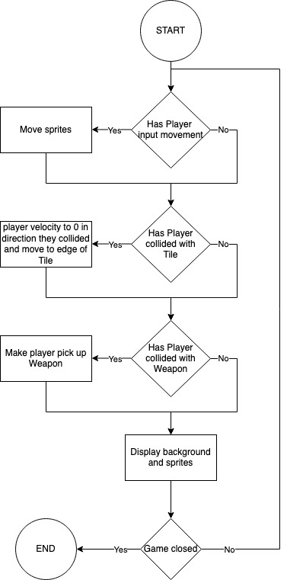

One cycle is completed every frame until the game is closed.

## The Basic Mechanics

The Players will be initialized and loaded into the game. Weapons will be spawned by weapon spawners and the Player will be able to pick these Weapons up. Once there is only one Player alive the living player will be announced as the winner and the next round will be started. To start the next round a new level will be loaded, players will be respawned, and all Weapons and Bullets will be removed.

## Menu screen design

Below is a simple mock up for the games starting menu screen:

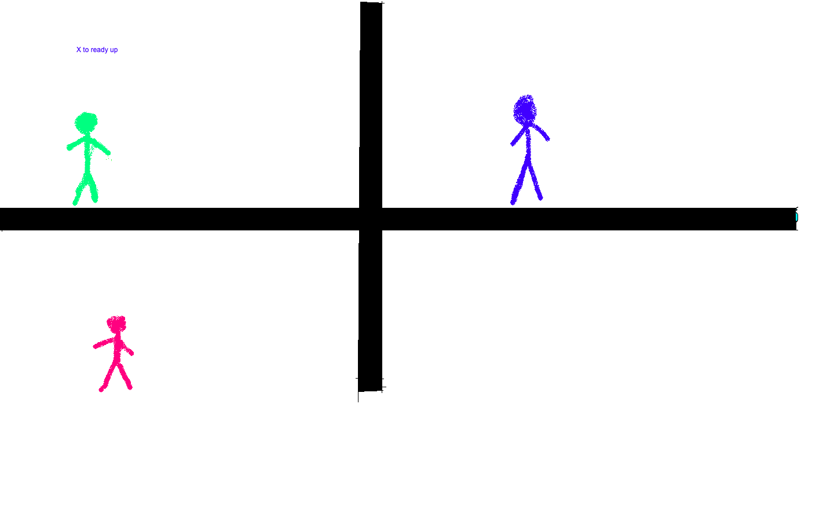The players will be able to press “X” on the controller or “E” on the keyboard to ready up. Once all players have readied up the game will begin, and the walls will disappear which will allow the players will be able to fight. Once there is a winner the game will start.

## Settings Menu Design

The settings menu will be accessible by either pressing the escape key on the keyboard or by pressing the “start” button on the controller. This will pause the game and blur the screen then bring up some options over the top. The arrow button will take the player back to the game where they can continue playing. The report bug button will take the player to the GitHub page where they can submit a bug report which will allow for me to find more bugs in my game and improve it. I am aiming to make the settings menu simple to use as that will ensure players spend as little time changing settings and spend more time playing the game increasing satisfaction with the game. Here is a mock-up of the settings menu using Canva.

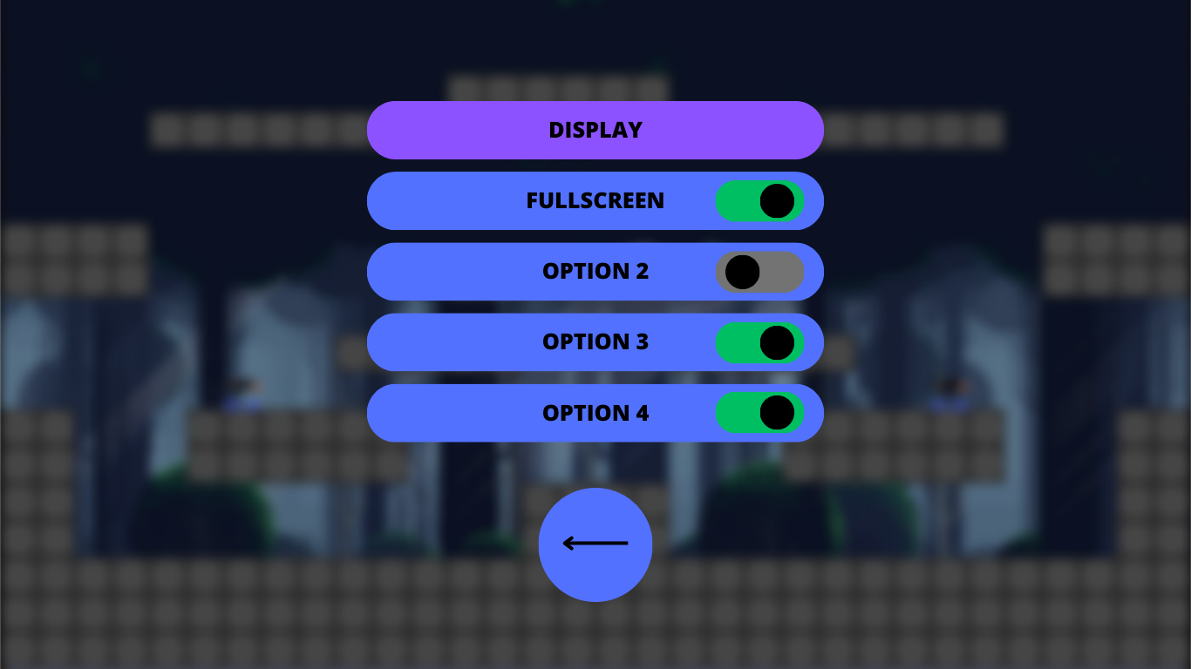

When the player clicks one of the buttons for display, audio or game options a second page will appear where they can change the options.

### Feedback from stakeholders

In a short interview with stakeholders I asked about their opinions for the design. I sent both of them an email that said: “Attatched is an image of a basic design for the settings menu. What is your opinion on the design, and do you think it is fitting for the platformer game that I am making”.

Matthew said: “I think the design is good and is simplistic which is all that I would want from a settings menu.”

George said: “The settings menu looks minimalist and clean. I think it fits the game well.”

Overall, the stakeholders were happy with the design of the settings menu and thought that it fit with the game.

## Creating the Settings Menu

I will be used (a pygame library for UI design) for the settings menu as it has large amounts of documentation and there are many tutorial on YouTube and other websites on how to use it. This will aid in the development. Also, it is a simple to use and well maintained python library so will continue to be useable with future python updates.

## File Structure

### First Iteration

The game will be stored in a python file called main. This will contain the functions and classes of the game. The game will largely use an object-oriented programming style. I will use inheritance for many of the classes in the game.

### Second Iteration

The games functions and classes will be stored in different python files and the files will be imported in places they are needed. This will mean that the code is more readable. For example, Player class is stored in player.py. More readable code means that the rate of development is faster understanding and finding the necessary functions is faster.

## Connecting interface devices

The game will use controllers and keyboard to interface with the game. The users can choose what they want to interface with the game with by pressing a button on the keyboard to use it or by connecting a controller to use controllers. This can all be done in the loading menu. The loading menu will prompt the user on what they want to use. A prompt to press any key or connect a controller should be sufficient. Once all the players have pressed a button (e.g. the X button on controller or the E key on keyboard) the game will start. The players will be put into the first level.

The benefit of allowing controller and keyboard inputs is that it increases the amount of people that can play as some people do not have controllers. Also, it allows those with both a controller and a keyboard and mouse to choose their favourite input method. The downside is that it means more input need to be added.

## Data structures of my program

I will largely be using an object oriented approach to my game. This is because many of the components are best represented as objects e.g. players. Here are some abstracted diagrams of the data structures of my game:

### Classes that inherit pygame.sprite.Sprite

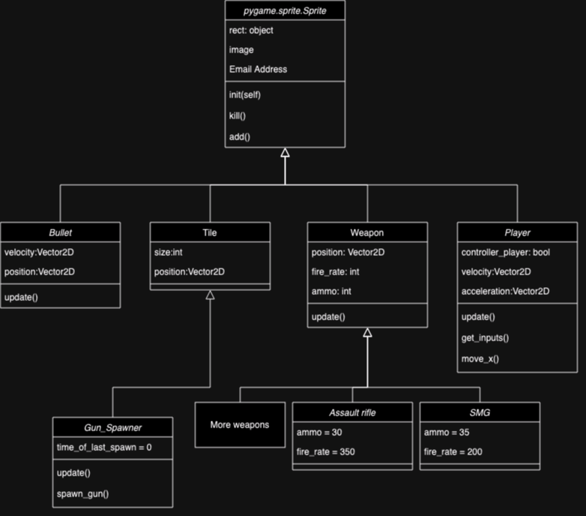

In the above diagram arrows represent inheritance. Pygame sprites are classes that have many features such as sprite groups which makes rendering many sprites to the screen far easier. For the weapons I chose to create one superclass that all weapons inherit as this reduces the amount of repetition in the code.

### Other classes

### First Iteration

In the first iteration of design, I stored all the functions and information in each level. Each level has its own set of players, guns and tiles. The levels are all created by a function in the main loop. The levels are stored in a list in the main loop and a counter decides on which level to run.

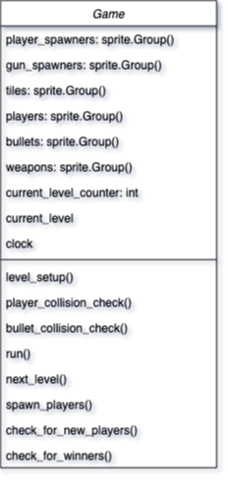

### Second Iteration

The levels are stored in a separate Level class which stores the tiles for the game and other parts that are specific to each level. These levels are stored within a list in the Game class. This allows for the same players to be used in different levels which makes the development of the game easier.

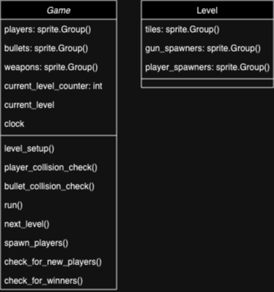

### Non-class data structures

|  |  |  |
| --- | --- | --- |
| **Data structure name** | **Type** | **Purpose** |
| Game.levels | List | Stores all of the levels that the player will play |
| Game.players | Pygame.sprite.Group() | A sprite group that stores all of the players that are playing the game |
| Game.bullets | Pygame.sprite.Group() | The bullets of the game |
| Game.weapons | Pygame.sprite.Group() | Stores all of the weapons of the game |
| Level.tiles | Pygame.sprite.Group() | Stores the tiles of each level |
| Player.idle_image_list | List | Stores all of the frames i |

## Key Variables

|  |  |  |
| --- | --- | --- |
| **Variable name** | **Type** | **Purpose** |
| Screen | Pygame.surface.Surface() | This is the surface that all of the sprites and components of the game will be displayed to |
| Player.position | Pygame.Vector2() | Stores the position of the players position |
| Player.alive | Boolean | Stores if the player is alive |
| Player.holding | Pointer | Stores a pointer to a weapon object. If player is not holding a weapon this is false |
| Running | Boolean | If true, the game loop continues. Is set to false when the game is stopped. |
| Clock | Pygame clock object | Stores the time in millis |
| Game.number_of_players | Integer | Number of players |
| Game.current_level_counter | Integer | The index of the current level in the levels list |
| Game.current_level | Pointer to level object | Pointer to current level object |
| Player.controller_player | Boolean | Whether or not this player is using a controller |
| Player.velocity | Pygame.Vector2() | A vector to store the velocity of the player |
| Player.acceleration | Pygame.Vector2() | A vector to store the acceleration of the player |
| Tile.health | Integer | The health of a tile |

## Algorithms

The program will be made up of many smaller algorithms that will each combine to make the larger program. Decomposition will be used to break the program into the many parts. Object oriented programming paradigms will also be used for encapsulation to contain some parts of the program within others. Below are the algorithms that will make up the program:

* Main loop
* Destruction
* Player movement
* Player collision
* Player aim direction
* Displaying the aim direction
* Shooting
* Loading the next level
* Spawning in players

## Main loop

The main loop is run every frame. This is where the game.run() method is called which calls other methods within it. Here is the psuedo code for the functions :

pygame.init()

screen = pygame.surface.Surface()

running == true

while running:

for event in events:

if event == QUIT:

running = false

break

game.run(screen)

## Destructible EnvironmentEnviroment

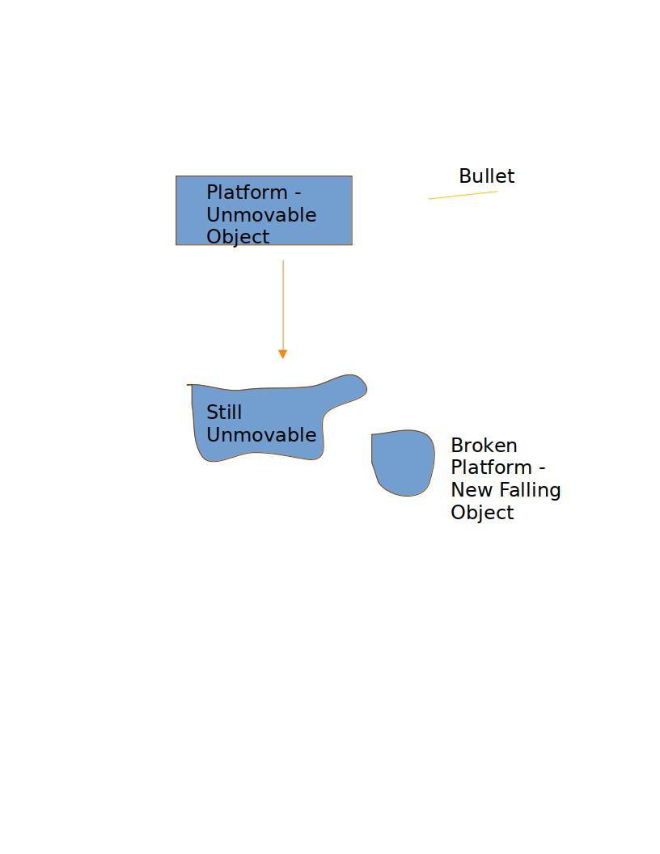In my game I want the tiles that make up the game to be destructible. This means that when shot the tile will break into pieces and fall. To do this I will implement a function that removes a tile if it is impacted by a projectile. The tile will be replaced with some pieces that interact with the tiles around it. To do the interactions with the tiles around I could use Pymunk (a python library for Pygame physics) or I could code my own solution. Coding my own solution will take a lot of research. This may not be within my time scale for the first iteration of the game.

Here is a simple diagram of how the destruction will work:

Here is some pseudo code of how this would work (lines are indented less than they should to increase readability):

def destory_tiles():

for tile in tiles:

for bullet in bullets:

if bullet.collide(tile):

new_moving_tile=Moving_Tile(tile.position)

moving_tiles.add(new_moving_tile)

tile.kill()

This function iterates over the tiles and bullets, checks for collisions, removes of tiles that have been shot and creates a new object in its place. The physics of the Moving_Tile object would be controlled by pymunk or a custom physics system of my own.

## Player movement

### First Iteration

A player will be moved by changing the position that their character is displayed to. For moving horizontally this is done by changing the position by a variable 2D vector called velocity that is given a value dependent on the keys being pressed (if neither the “A” or “D” key is being pressed x_velocity is set to 0) or the direction of the joystick (). The jumping is done by setting the y velocity to be a value. The velocity is then decreased by a gravity acceleration constant. This gives a smooth jump parabola. With the joystick movement the amount that the joystick is pushed can be used to control the movement. Also to decrease the affect that joystick drift (when controllers are used for too long the potentiometers in the motion detector is worn down leading to the joysticks giving false positives for movement) has on the game a joystick has to be moved more than a certain distance to move the player.

Here is the pseudopsuedo code (This is not the whole player class):

RUN_SPEED = 2

JUMP_SPEED = 4

GRAVITY = .2

Player(Sprite()):

def __init__(controller_player): #called on intialisation

position = 2dVector(0,0)

velocity = 2dVector(0,0)

def update(): #called on each frame

get_inputs()

apply_gravity()

position += self.velocity

def get_inputs():

if controller_player == false:

#horizontal movement

if get_key(“D”):

velocity.x = VELOCITY

else if get_key(“A”):

velocity.x = VELOCITY * -1

else:

velocity.x = 0

#verticle movement

if get_key(“W”) and on_ground:

velocity.y = JUMP_SPEED

else:

#get joystick is a function that returns a

#2dVector of the joys position (-1 to 1)

joy_position = get_joystick().x

if modulus(joystick_position)>0.2:

velocity.x = joy_position * RUN_SPEED

if get_joystick_button(2):

velocity.y = JUMP_SPEED

def apply_gravity():

velocity.y -= GRAVITY

### Second Iteration

A player will be moved by using a variable 2D vector called acceleration that is dependent on the buttons pressed. This variable is added to the velocity vector each frame which is added to the position. This makes the movement more fluid and realistic as changes in direction are not immediate. I will also use a function that limits the velocity to a maximum that is a constant. When the player is not pressing a button/ pushing a joystick to move in the X direction the velocity of the player will be decreased by a friction constant. I will also use a variable called dt that will be the time that has passed between one frame to another. This stops the framerate the game is running at from affecting the speed that the player moves.

RUN_SPEED = 2

JUMP_SPEED = 4

GRAVITY = .2

Player(Sprite()):

def __init__(controller_player): #called on intialisation

position = 2dVector(0,0)

velocity = 2dVector(0,0)

acceleration = 2dVector(0,0)

def update(): #called on each frame

get_inputs()

apply_gravity()

position += velocity

def get_inputs():

if controller_player == false:

#horizontal movement

if get_key(“D”):

velocity.x = VELOCITY

else if get_key(“A”):

velocity.x = VELOCITY * -1

else:

velocity.x = 0

#verticle movement

if get_key(“W”) and on_ground:

velocity.y = JUMP_SPEED

else:

#get joystick is a function that returns a

#2dVector of the joys position (-1 to 1)

joy_position = get_joystick().x

if modulus(joystick_position)>0.2:

velocity.x = joy_position * RUN_SPEED

if get_joystick_button(2):

velocity.y = JUMP_SPEED

def apply_gravity():

velocity.y -= GRAVITY

def move_x_axis():

velocity.x += acceleration.x

if velocity.x > 0: velocity.x += player_friction

else if velocity<0:velocity.x -= player_friction

if velocity.x > PLAYER_MAX_SPEED:

velocity.x = PLAYER_MAX_SPEED

else if velocity.x < PLAYER_MAX_SPEED:

velocity.x = -PLAYER_MAX_SPEED

if abs(velocity.x) < 0.5: velocity.x = 0

## Player collisions

### First Iteration

This can be done by splitting the movement into the X and Y components which makes determining the direction of collision easier. Next the game determines if there was a collision in each direction and determines the if the player was moved in the positive or negative direction. Finally, the game moves the player to one of the sides of the tile and sets the velocity to 0.

def player_collision_check():

for player in players:

player.position.x += player.velocity.x

for tile in tiles:

if player.collide(tile):

if player.velocity.x > 0:

player.position.x = tile.position.x

else if player.velocity.x < 0:

player.position.x = tile.position.x + tile.size

player.velocity = 0

player.position.y += player.velocity.y

for tile in tiles:

if player.collide(tile):

if player.velocity.y > 0:

player.position.y = tile.position

else if player.velocity.y < 0:

player.position.y = tile.position.y + tile.size

player.velocity.y = 0

### Second Iteration

The second way to do this is by checking only the tiles around the player. This reduces the load on the cpu and makes the game O(1) for the number of tiles instead of O(n) which is important for large levels.

## Finding the direction the player is aiming

I will need to design two different functions for this since the controller player and the keyboard and mouse players use different methods of aiming.

### Keyboard

For the keyboard player I need to find the “offset” of the mouse from the player. Then I can divide this offset by the distance of the player from the cursor. This gives a normalised coordinate of where the player is aiming. This can be used to set the velocity of the bullets that the player shoots.

def player_aiming_direction:

mouse_offset_x =mouse.position.x – player.position.x

mouse_offset_y =mouse.position.y – player.position.y

mouse_offset_dist = sqrt(mouse_offset_y ** 2 + mouse_offset_y ** 2)

aim_direction.x = mouse_offset_x / mouse_offset_dist

aim_direction.y = mouse_offset_y / mouse_offset_dist

### Controller

The controller player will use the right stick as the method of aiming. Using the joysticks in pygame can give a value that ranges from -1 to 1 for the x and y coordinate.

Joystick drift needs to be taken into account. This can be done by setting the aim direction to (0,0) if the joysticks are not pushed passed a threshold value.

The left stick will also need to act as a method of input for aiming when the player is not aiming with the right stick. This will also be implemented in the same way as for the right stick.

When neither the left or right stick is being pressed the player will either shoot in the direction they last shot in or they will shoot in a random direction. For the first iteration I will use the random direction method.

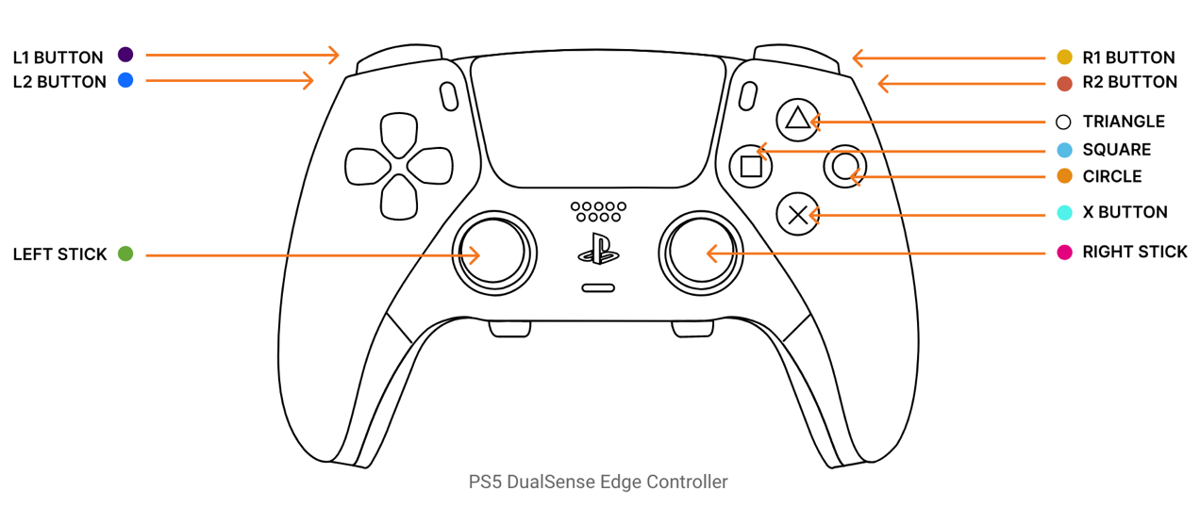

def player_aim_direction:

right_x_offset= controller.right_joystick.position.x

right_y_offset= controller.right_joystick.position.y

right_distance = sqrt(right_x_offset**2 + right_y_offset**2)

left_x_offset=controller.left_joystick.position.x

left_x_offset=controller.left_joystick.position.x

left_distance = sqrt(left_x_offset**2 + left_y_offset**2)

if right_distance > 0.1:

aim_direction.x = right_x_offset

aim_direction.y = right_y_offset

elif left distance > 0.1:

aim_direction.x = left_x_offset

aim_direction.y = left_y_offset

else:

aim_direction.x = 2*random.random()-1

aim_direction.y = 2*random.random()-1

## Displaying the direction the player is aiming

The direction the Player is aiming will only be displayed if the Player is using a controller as the keyboard Players have the cursor to indicate where their bullets will go.

With the controller players a simple circle (maybe the same colour as the player) to indicate where they will shoot can be used. There will only be an indicator if the player is aiming with the right joystick. The indicator will be a circle that is drawn relative to the Player that is aiming. The position relative to the Player will be based off of the position of the right joystick.

#a method within the player class to draw aiming #indicator

def draw_aiming_indicator():

offset_x = get_joystick().x * INDICATOR_DISTANCE

offset = get_joystick().y * INDICATOR_DISTANCE

draw_circle(offset_x + player.x,offset_y + player.y)

## Shooting

The shoot program is a method within the Player that creates a new Bullet object and sets its velocity to be the aim_direction multiplied by a speed. The bullet object is added to the games bullet sprite group Here is pseudo code of the function.

def shoot:

bullet = Bullet((position.x, position.y), aim_direction.x * bullet_speed, aim_direction * bullet_speed) #Bullet(position, velocity)

game.bullets.add(bullet)

## Loading in the next level

First the level counter is incremented, and the current level is set using the level counter as the index for the level to load. Secondly, all of the bullets and weapons are killed. The Players’ spawned attribute is set to false and the holding attribute is set to none/null. The spawned attribute for all player spawners is set to false and the spawn_players method is run.

def next_level():

for player in players:

player.spawned = false

for bullet in bullets:

bullet.kill()

for weapon in weapons:

weapon.kill()

current_level_counter += 1

current_level = levels[current_level_counter]

## Spawning players

This iterates through every Player in the players sprite group and checks if the players’ spawned attribute is true. If false, the algorithm spawns the player on one of the player spawners that has not been used. This will be a method within the Game object.

To spawn the players the Player object will be moved to the correct position by changing the position coordinates to be the same as the spawner’s coordinates.

def spawn_players():

for player in players:

for spawner in current_level.spawners:

if spawner.used == false and player.spawned == false:

player.position = spawner.position

player.spawned = true

spawner.used = true

## Permanent Storage

The game will have very little permanent storage as the project does not need to store much information however players are able to edit the level files to add their own levels or to remove levels. This file is not changed by the game but is read by the game for creating the tiles sprite groups. One feature that I could implement is a scoreboard system that stores the best scores that players get in the single player mode in a simple text file. Overall, the permanent storage for the game is very small.

## Method of distribution

I plan to use PyInstaller will be used to create an executable. Also, for users of different operating systems they will be able to run the game as long as they install python. Also, a python package will be created which means if someone wants to install the game, they will not need to install all the prerequisites such as pygame.

## Deciding between aggregation and composition

Much of my program will use composition. This is where an object only exists within another object. An example of this is the Levels objects that are initialised within the Game object. Composition allows for encapsulation of the functionality of the contained objects within the container. This keeps the code clean and clear. Also, the composition implies ownership which is true of the classes within my program. The Players, Levels, Weapons and Bullets are all owned by the Game object.

## Local and global variables

Throughout the program local variables will be used. This is because it provides encapsulation to the code which increases the readability and cleanliness of the code. When variables need to be used by an object that is initialised within another, variables will be passed by reference into the program. Passing by value will only be carried out for functions that return values.

## Validation

Inputs should be validated to ensure the correct data is being inputted. These are the types of data that can be input:

### Keyboard buttons and Controller inputs

All of the keyboard buttons and joystick inputs are input through pygame. I can use selection and a pygame function to check if a button is being pressed. Selection can also be used to determine if the player should be able to press a button (validation):

* If the player is on the ground, then they can jump with “W” key or the “A” button on controller
* If the player is intersecting a weapon, they can pick up the weapon with “E” key or the “Y” button on controller
* If the player is holding a weapon, they can use the weapon with mouse click or right trigger on controller. Also, on controller the user must push the trigger further than a set point for a bullet to be shot. This reduces the number of accidental shots from slight presses of the trigger.

### Reducing the effects of stick drift in my game

Stick drift is where a controllers detect a movement when the joystick is not being moved. This happens because of wear on the potentiometers and because of badly designed controllers. To counteract this, the player only moves when the stick is pushed beyond a set point defined as a constant. This stops the player sliding with bad controllers or aiming in a direction they do not want to.

### Sliders

These can be handled by Tkinter to input data for the settings menu. Tkinter has a UI that can be useful for designing the menu system. Users should only be able to move the slider to a maximum and minimum value.

### Toggle switches

These can be toggled on or off. These will also be handled by Tkinter. When on the user should only be able to switch them off and when off they should only be able to switch them on

## Type of Development

## Testing

In testing of the code, I will be using both white box and black box testing. Whitebox testing is where we focus on the internal mechanisms of the program and determine how an output is achieved. This can be useful for testing how optimal the program is. It is also a very thorough method of testing as all of the program is inspected. The downside is that whitebox testing is slow. Blackbox testing is a faster method of testing where the internal mechanisms are ignored and only the output of the program is important. Two types of blackbox testing that will be used are integration testing and unit testing. Unit testing is where individual parts of the program are considered. Integration testing is determining how individual parts link together. These two methods can be used to check if the program is working very quickly. One method may be use is automated unit testing. This is where unit tests are made after the creation of each unit then run automatically. These are very quick. Beta testing can also be used with a sample of my users to determine if the program is effective in solving the problem set out in the problem specification.

To gather data for the purpose of maintenance I will implement some way for users to report issues back to me. This could be done by putting an email or a link to report an issue on the GitHub repository, in the menu or could implement a system where information about the game is sent along with the users problem when they press a button in the settings menu. The second option would give me more information to make decisions on but would require more work to implement.

I have set out the test criteria that will be used within the success criteria within the analysis section.

## Inputs and Outputs

|  |  |  |
| --- | --- | --- |
| **Input** | **Process** | **Output** |
| The “D” or “A” key is pressed on the keyboard OR left or right on the joystick of controller | The Players x position is increased or decreased to move the player | The image of the Player will move, and animation will change |
| The “W” key is pressed on the keyboard OR the “A” button is pressed on the controller | The Players y velocity is increased. | The Player will first move upwards then slow before moving downwards towards the floor. They jump. |
| When holding a weapon, the player clicks the mouse or the y button on the controller. | A bullet is created and moves in the direction the player is aiming. | The player shoots. |
| The Player moves the mouse in a direction. | The program finds the direction of the mouse from the Player | The Player aims in that direction |
| The Player moves the right joystick in a direction | The Player finds the direction of the joystick | The Player aims in that direction |

# Development

## Stage 1 - Displaying the Levels

### ****Creating a basic game loop****:

The first step of development was creating the basic game loop and displaying a simple shape to the screen. The code used from the [Pygame documents](https://www.pyga.me/docs) to create the basic loop. The pygame.draw was used function to draw a circle to the screen.

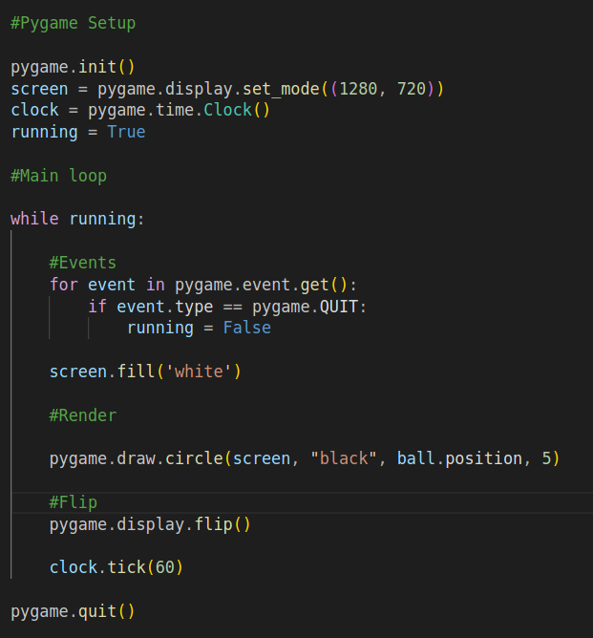

When this code runs run it creates a window and displays this to the screen:

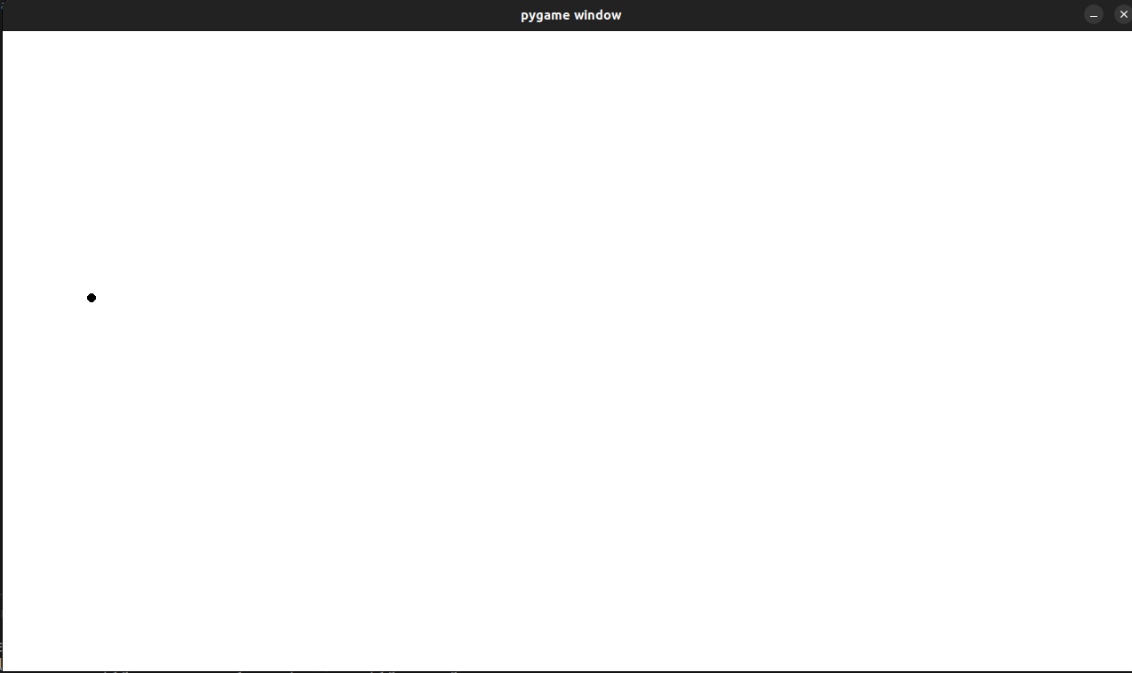

I was happy with the result so moved on.

### ****Displaying a level****

A class was produced called Tile() that is a sub class of Pygame.sprite.Sprite. This takes in a position and sets the coordinates of the rectangle to be drawn at that position.

To test this I created a test tile and drew it to the screen:

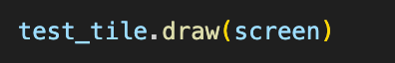

This worked without any problems:



A method was created that uses a string to get the layout of the level. The function determines where each of the tiles should go based on its position in the list of strings. It then initiates a Tile with the position and adds it to a sprite group called self.tiles. Sprite groups are a feature of Pygame that allow for rendering a group of sprites all at once.

The method is a member of the level class that stores the string that makes up the level. It is called in the initialization of the level object and creates the self.tiles sprite group.

The code for these is below:

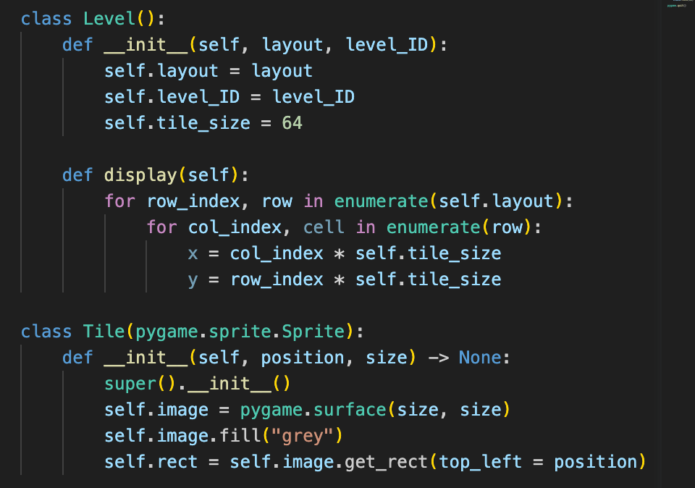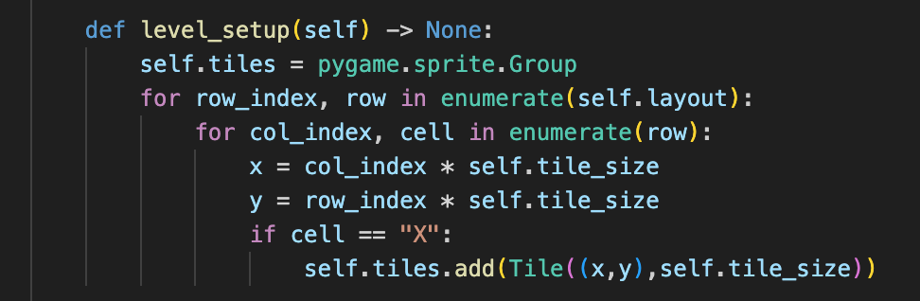

The test Tile was removed and then the game was tested with a test level instead. The test level was just a list of strings. Here was the result after debugging syntax errors:



## Stage 1 evaluation

This stage was successful in creating a system for displaying the tiles.

## Stage 2 - Storing levels in txt files

Initially, a levels folder was created which contained some txt files containing the layout of the game. The built in os library was used to create a simple program that was made in a separate python file called test.py. By creating the function in a separate program the function can be tested without interference from the other parts of the program.

The program opens a directory and iterates through the folders in that directory it creates a list and for each file it iterates through the lines then appends each line to the list. This puts it in the same format as the level_setup method.

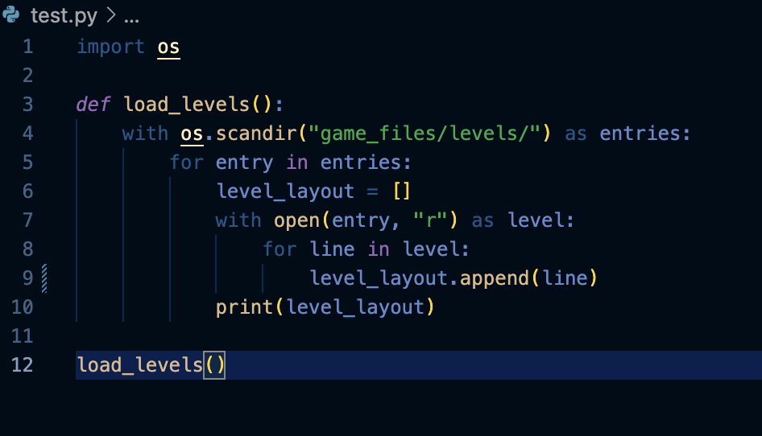

At first when testing I found that each string contained “\n” at the end.



This happens because the “\n” is used as a character to determine where there should be a line break. To fix this I used the strip() function to remove “\n” from each line.



This worked and when testing a second time the program printed this to the terminal.



There is no “\n” in the strings so they a can be used by the level building program properly.

## Stage 2 evaluation

This function was successful in loading files from the memory. It took a short amount of time to create but is robust and loads files from memory consistently. In the future, the levels need to be ordered by the name but for now the function is sufficient.

## Stage 3 - Creating the Player

First I made a class called Player that was a subclass of the pygame.sprite.Sprite. A red image was given to test and also added some logic for checking if the buttons on the keyboard were pressed (the WASD keys) so that the player would move in those directions if they were pressed.

Secondly, a function was added in the level program that detects collisions. This differed from the algorithm proposed in design slightly as it used a few parts of pygame to check if there was a collision (the colliderect method) and used parts of sprite rects such as left and right position.

Here is the code I used for the collision_check for the player:

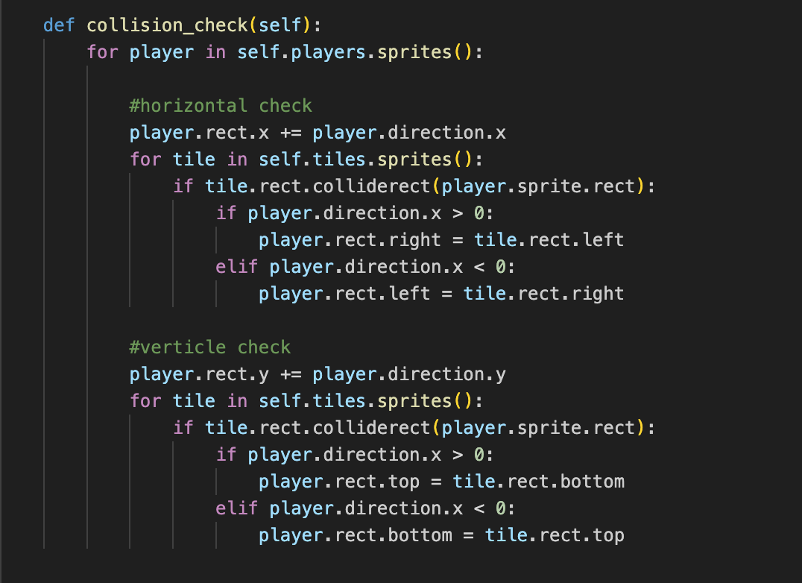

This was a method within the Level class.

After testing the program collision worked properly however the player could move in any direction they wanted as there is no method for the player that adds gravity.



### ****Gravity****

To add gravity, I created a method in player called add gravity that added a constant (called GRAVITY) to the y velocity of the player. This means that if the player is in the air they will be accelerate towards the ground. Also, the “W” key on the keyboard changes the players velocity to an a constant amount but can only be pressed if the player is on the ground.

**Finding the aim direction and displaying indicators**

At first, a function was implemented similar to that of the design. However, the speed of bullets were dependent on how far the joystick was being pushed from its normal position. This was not what was wanted as bullets differed in speeds. To correct this the directions were normalised. This means that both the x and y offsets were divided by the distance from the centre. Here is the code for this function. Here is the code used.

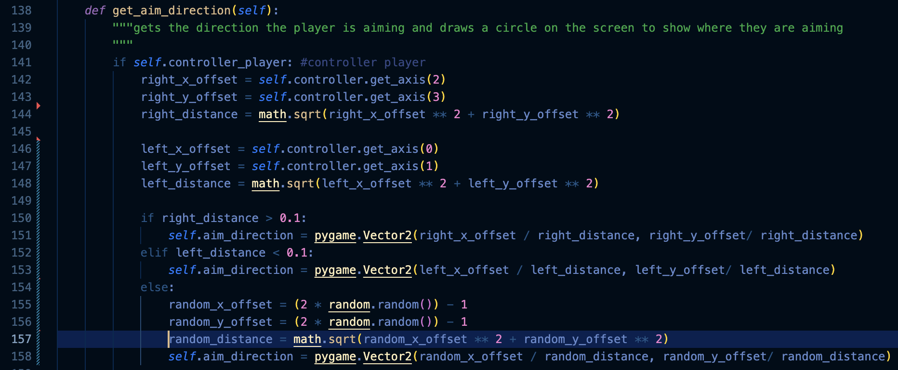

This worked well. All bullets were travelling at the same speed no matter the position of the joystick.

Next, it needed to display the direction that player is aiming. This was done by displaying a small circle with the coordinates of the player plus an offset. In testing I found that the cursor did not seem to be centred around the middle of the player as it should. To fix this, the half the width and height of the player was added to the aim_cursor_position. Here is the code that I used:



Here is an image of the cursors:

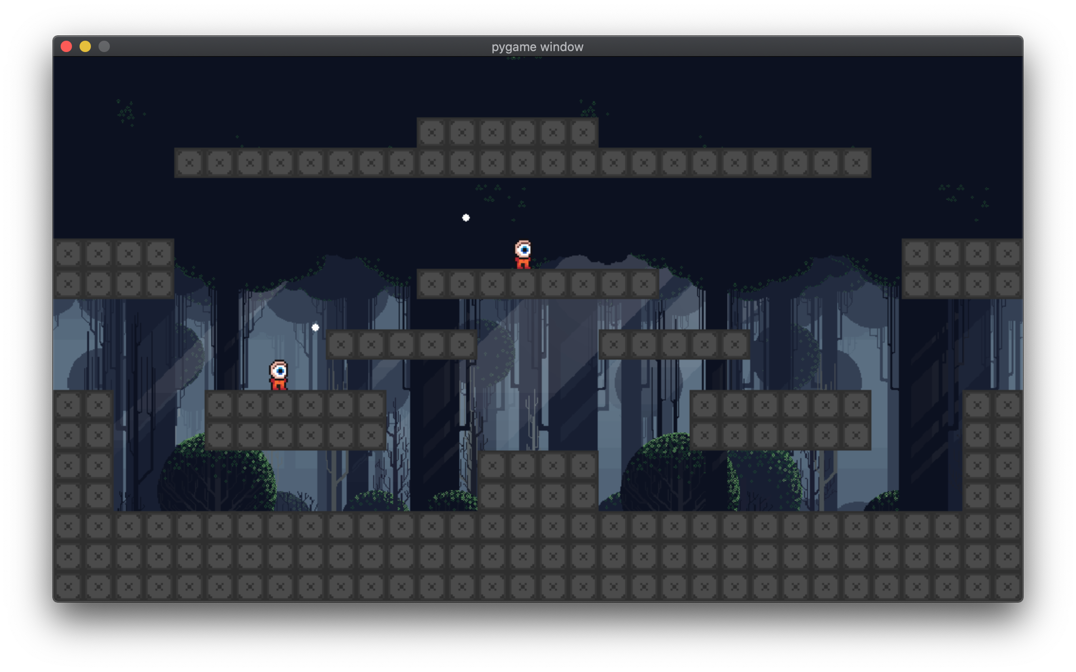

They appeared to be centred around the player, therefore the next task was working on weapons.

## Stage 3 evaluation

The development of the player was effective. In the future, to improve the movement physics for the player and adding animations is required. For now, the Player class is effective. Also, adding new methods for weapons is required.

## Stage 4 - weapons

### Weapon class

The Weapon class is a sub class of sprite class. It is used as a super class for each individual weapons.

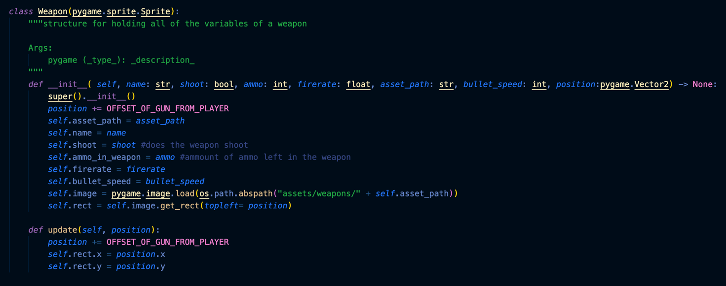

It has attributes for a few different properties of each weapon.

Here are two examples for the ak47 and smg classes:

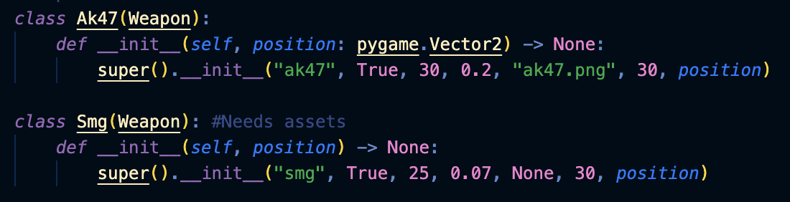

These are used by the weapon spawners.

### Weapon spawners

These are a type of tile that spawn weapons at regular intervals. They are spawned in using the same function the rest of the tiles use. They have no collision. 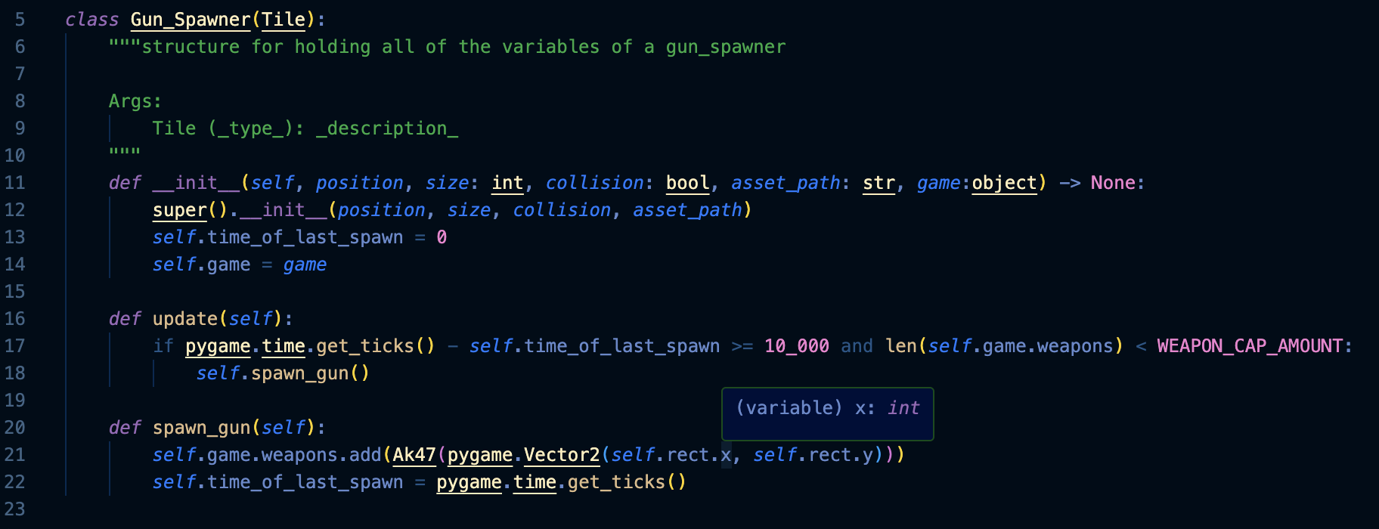

The update function is called in the game update function. Every 10 seconds the spawn_gun function is called given that there are not too many guns in the level already.

This worked well and the game spawned weapons properly. Here is a [video](https://drive.google.com/file/d/1rsIVOmUg2PJ5HekNwQeb5ymmcReF4THN/view?usp=drive_link) of testing.

### Players Interaction with weapons

Players pick up weapons when they are colliding with the weapon and they press the weapon pick up key. When they do this the players holding attribute is set to be the weapon it is colliding with. The weapon is moved to be at the position of the player. This means the weapon moves with the player. Here is the code that moves the weapon:

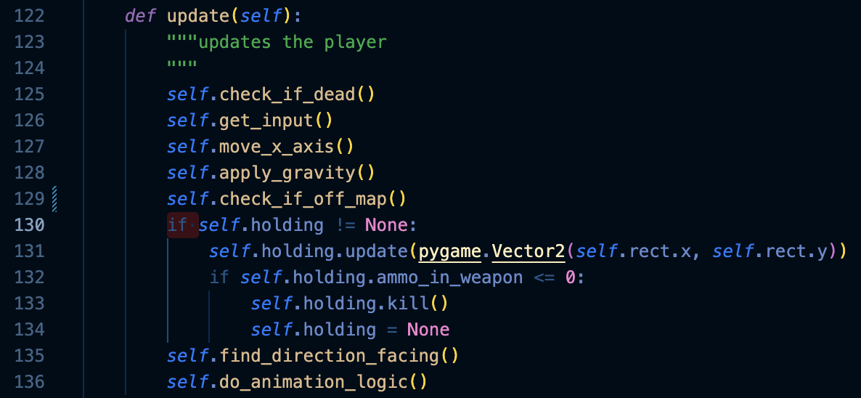

### Ammunition with weapons

When a weapon is shot its ammo attribute is decreased by one. Once the ammo attribute is decreased below 0 the gun is killed and the player’s holding attribute is set to None.

The code for this can be seen in the image above.

This all worked as expected. Here is an image of the player holding a weapon.

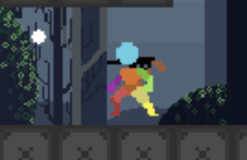

### Shooting

Shoot is a method within the player class. It initialises a Bullet and gives it a velocity that is based on the direction the player is aiming and the speed of the bullets that the weapon that the player is holding. It also decreases the ammo by one. Here is the code.

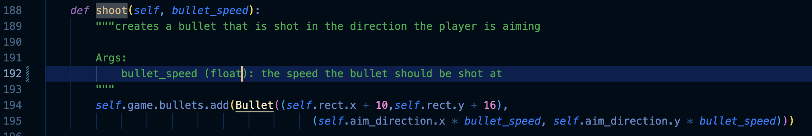

This works as it should. Here is a [video](https://drive.google.com/file/d/14C71e82aU45I4nZDnsftCJ-rCywMbGSl/view?usp=drive_link) of testing.

## Stage 4 Evaluation

This was effective in creating a weapon system that worked for the weapons I need at this moment. In the future, it would be better to add new weapons and new weapon types such as rocket launchers.

## Stage 5, Changing the structure

Since the original structure of the game would be difficult to work with further into the game I decided to change the structure of the game to iteration 2 that can be seen in the design. Here is the code used:

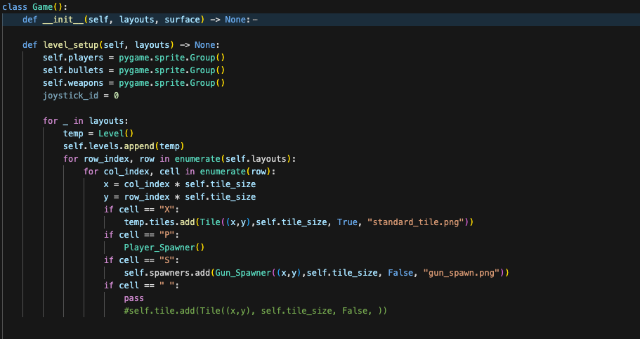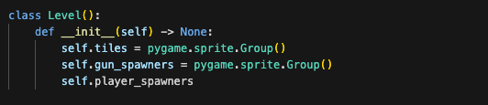

In testing of this code, it was found that the levels were not being displayed properly. 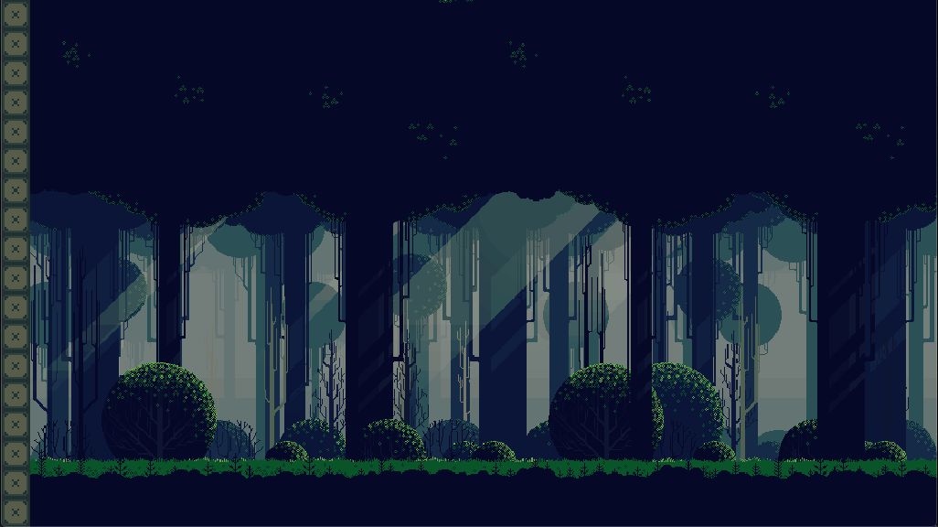

To investigate the cause of this issue I printed the layouts.



This showed that the levels were being passed into the game function as a list of maps but the program was trying to read the “layouts” as if it was a single map. This resulted in the bug that can be seen. This was fixed by reading the layouts as a list and adding each as a level.

This worked so the print function was removed. Here is a screen shot of the level after the bug was fixed:

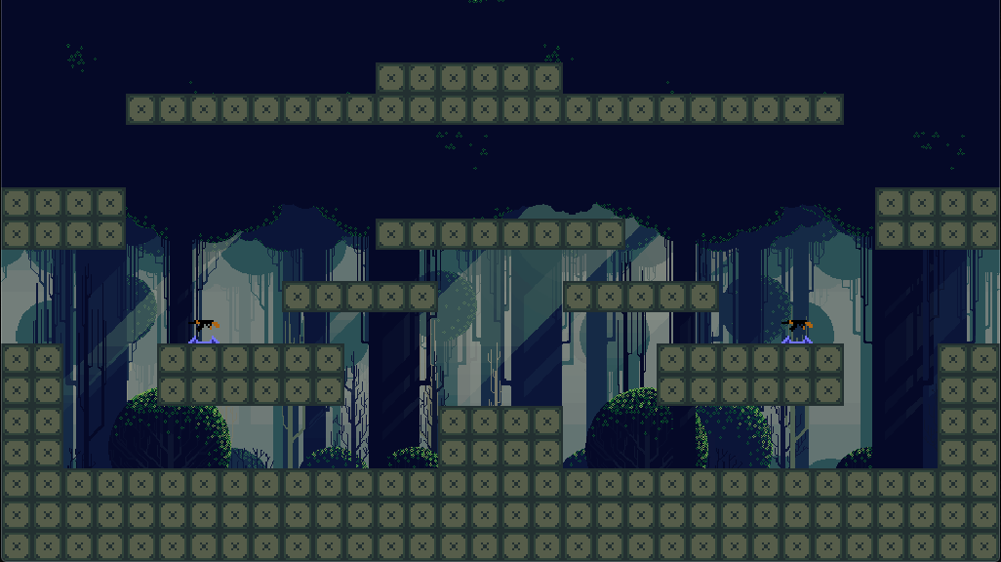

A way to move through the levels was needed since the method that levels are being done was different. A function was created that gets called whenever the player presses the “p” key for testing to move through the levels.

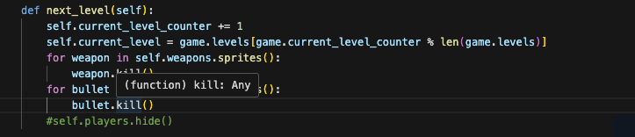

This function removes all of the non-permanent parts of the game (e.g. the weapons and bullets) and loads the next levels permanent parts (e.g. the tiles). Later I will move to the next level when someone has one the round.

I created a function that spawned in the players when they hit a button on the keyboard (“e”) or when they plugged in a controller for the first time.

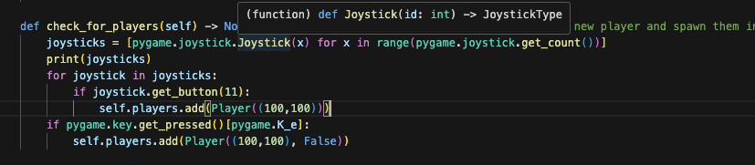

[Here](https://drive.google.com/file/d/11PVkdxy5DVjoaSnns7CypnW7Pe5-l2Tl/view?usp=drive_link) is a video of testing. When pressing e to spawn the keyboard player many players were being added. This was happening every frame. This was corrected by adding a keyboard player spawned attribute. This meant that the keyboard player could only be spawned once.

Also, a method was needed for moving the players into the correct place after the level was loaded as unlike before the players are the same objects throughout the game. This was the same as the algorithm in the design.

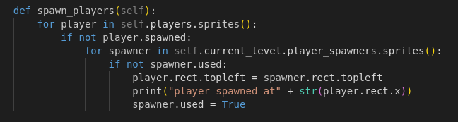

## Stage 5 evaluation

This stage was effective in creating a system that would be more robust where the same player could be used for different levels. This makes keeping track of which controller is assigned to which player and the score of each player far easier.

## Stage 6 - Splitting game into multiple parts

To increase the readability of the code I separated the code into multiple files. This improves the speed at which development can happen as finding code is easier. To do this I used the import keyword in python to load the parts needed for each file.

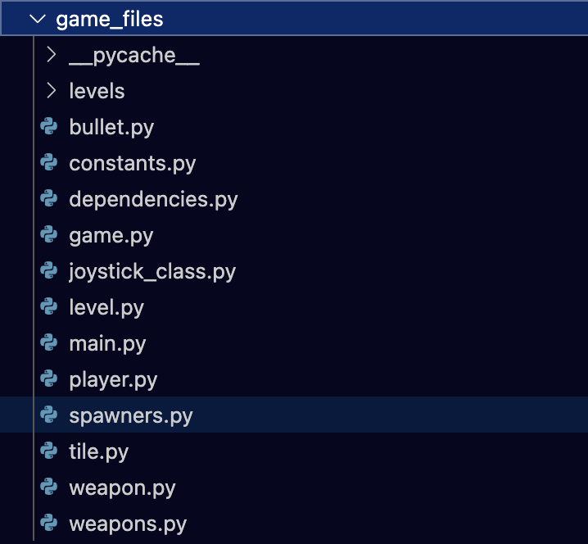

The game file imports these dependencies: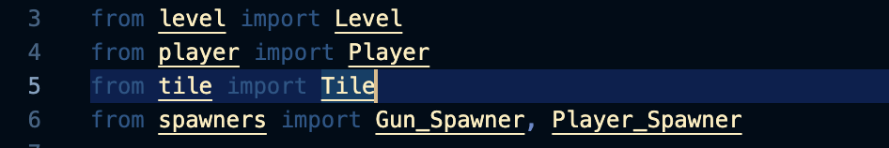

## Stage 6 Evaluation

This functioned well and increased the readability and cleanliness of the code.

## Stage 7, Animations

### Changing the direction that the player is facing

Players need to be facing to the left when they are moving to the left and facing to the right when they are moving to the right. To do this, the image was flipped and will be used for the player and store it in a list with the normal image. I can then choose which image required to use depending on the velocity of the player.

Here is the code for that:



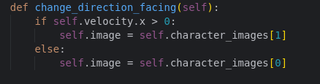

### Player animations

There was also the need to create player animations. The player should run when they are moving and idle when they are standing still.

A free asset pack was found which contained a sprite sheet of different player animations for different scenarios. Also using a free program to “unpack” the images from the sprite sheet made it easier to use in pygame and individual frames/images were placed into a folder.

Two lists were created that contained the reversed and normal frames for the animation. The os library was used to fill these lists.

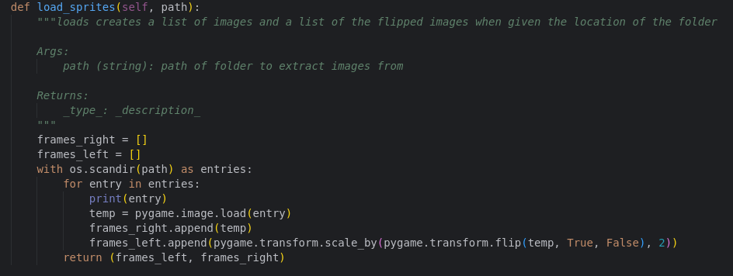

When displaying the lists I found that the animation did not look right. I printed the contents of the frames lists. <DirEntry '9.png'> <DirEntry '4.png'> <DirEntry '3.png'> <DirEntry '2.png'> <DirEntry '7.png'> <DirEntry '8.png'> <DirEntry '6.png'> <DirEntry '0.png'> <DirEntry '5.png'> <DirEntry '1.png'> <DirEntry '4.png'> <DirEntry '3.png'> <DirEntry '2.png'> <DirEntry '7.png'> <DirEntry '6.png'> <DirEntry '0.png'> <DirEntry '1.png'> <DirEntry '5.png'>

DirEntry stands for directory entry. The second part is the name of the entry. This showed that the images were not being loaded into the list alphabetically. This was fixed by sorting the entries list:

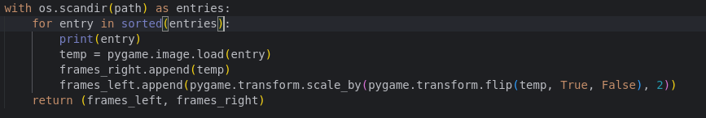

However this resulted in an error:

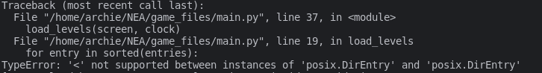

The sorted function was used to try to sort the items based of each item in the list. However, the items are classes and not strings so the sorted function cannot sort them. This is the fix made to improve the method.



This uses Lamda to use the entry name as a key to sort the strings instead of the entry.

I printed the contents a second time to check if it was working:

 <DirEntry '0.png'> <DirEntry '1.png'> <DirEntry '2.png'> <DirEntry '3.png'> <DirEntry '4.png'> <DirEntry '5.png'> <DirEntry '6.png'> <DirEntry '7.png'> <DirEntry '8.png'> <DirEntry '9.png'>

All of the entries were in alphabetical order, so they were being loaded in properly.

To display the animation a tracking of the frames was required. A counter was created that is incremented every frame and is only changed every eighth frame (an arbitrary number which may be changed in the future). Also, depending on the player direction the program chooses between the left facing and right facing images.

This was an improvement. The player was animated but since the function changed the size of the rect, the player would teleport through walls. Here is a [video](https://drive.google.com/file/d/1gQfry-BVCYTAtuLjvyaWSlnBKic7sTk7/view?usp=drive_link) of the problem. It was assumed that the Player was entering the walls and the program “thought” that the Player had collided with the ground in a direction that it had not. To fix this I would either have to change the game to use images that all have the same size (This would mean that the players hit box would be larger than it appears to be and this could take away from gameplay). Instead I set the rect to be be set from the bottom left of the player. This stopped the problems with the falling through the floor however when the player jumps and hits their head on the roof the player can move teleport through the ground above them.

Next I added some logic that determines if the player is moving in the x axis and shows the running animation if they are.

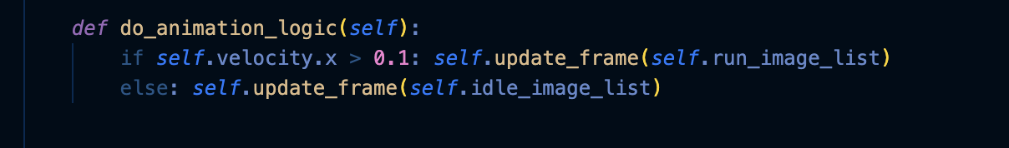

## Stage 7 Evaluation

This stage effectively created animations in the game. The system that was created is generalised and is capable of taking many different animations. It is possible to input a different set of animations or more animations and the system will handle them automatically. This is important for future development as many different animations will be used for crouching, jumping, landing, etc.

## Stage 8 – Improving the player movement

Instead of increasing the players velocity when left or right is pressed the new input function will change the players acceleration. 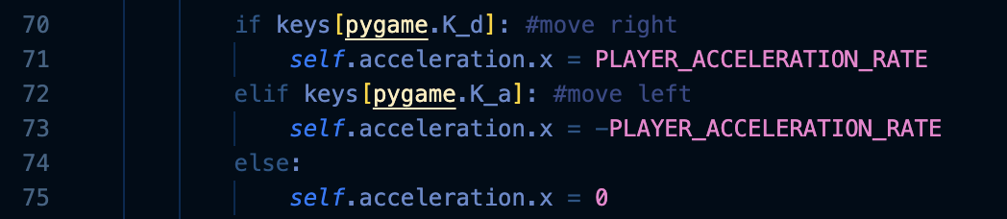

A similar function is used for controller inputs but position of the joystick alters the amount of acceleration.

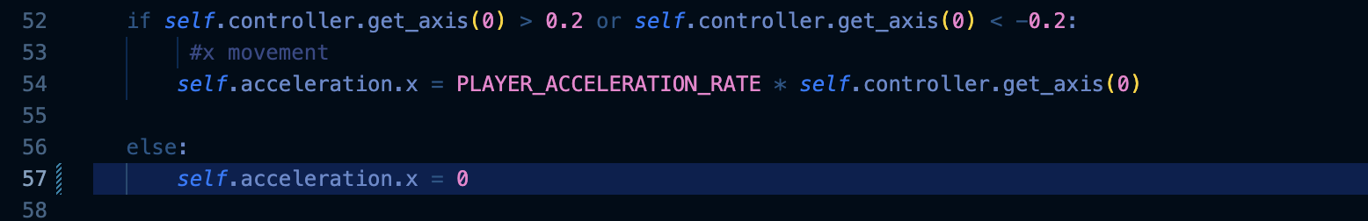

Next a new function for moving the player on the x axis is needed.

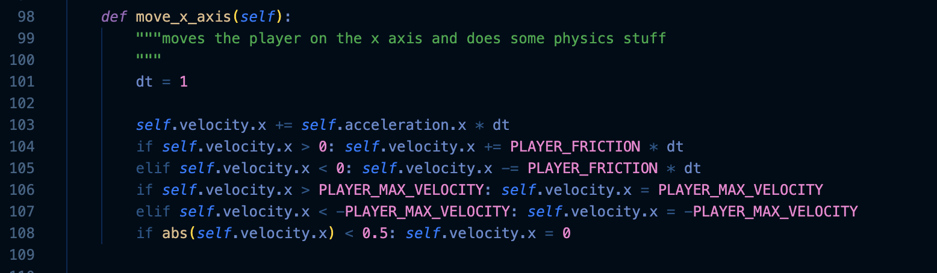

This function does a few things. In first instance, it adds the acceleration to the velocity. Then it removes the friction from the velocity. It then continues to limit the velocity of the player to a fixed amount. Next if the player is moving very slowly the velocity is set to 0. This stops residual movement. Finally, within the game object the players velocity is added to its position as before.

## Stage 8 evaluation

This stage took a large amount of work, but the final outcome was effective. In the future I would like to properly implement dt to ensure that the framerate of the game does not affect the speed of the players.

## Stage 9 - Basic Destruction

To start with I implemented a line of code within the physics method in the game class that killed a tile if it collided with a bullet.

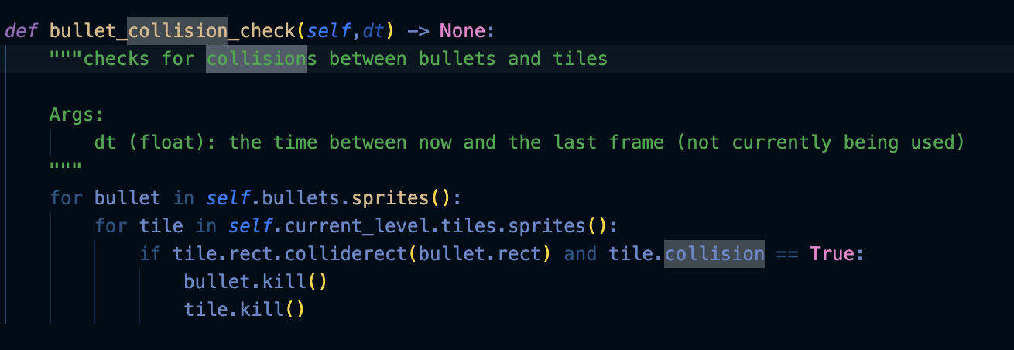

This worked and the user can now shoot a tile and destroy it. Here is a [video](https://drive.google.com/file/d/14x8TmlIl8jKYmk9Qjulx7LAkD0tHa7Ua/view?usp=drive_link) of the destruction mechanic.

Next, a way of adding damage to the tiles was required. First, the Tiles were given a health attribute. And made a damage method. If the tiles health went below 0 it is killed.

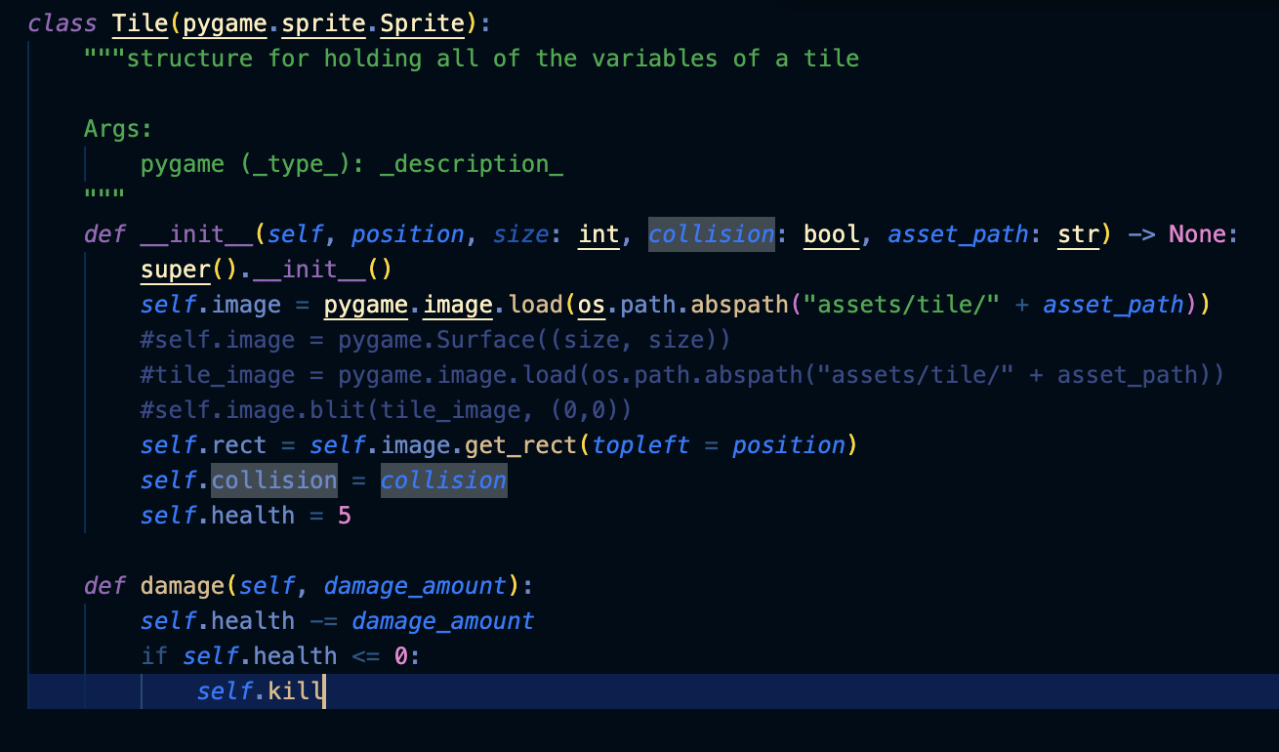

The kill line was removed and changed it to tile.damage(1) in the bullet_collision method.

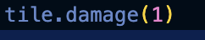

When testing it was found that the tiles would not break even after more than 5 hits from the weapon.

To understand the problem a breakpoint was added onto the point where the tile.damage function is being called. The health was found to be dropping below 0 and not killing the player despite the self.kill function being called. It was found that the lack of brackets on the self.kill function were the problem and after adding them the program worked properly.

Here is a [video](https://drive.google.com/file/d/1WyyRVfwBgOnxXU7Vuy51nteYcn8bY3du/view?usp=drive_link) of the working destruction. As you can see it now takes multiple hits for a tile to be destroyed.

## Stage 9 Evaluation

This system was easy to implement however the destruction system works by removing tiles. This means that when the level cycles back around it will contain broken tiles at the start of the round. In the future the use of a death system where if a tile is “dead” then it will not be display or used. Once the round finishes all tiles are set to alive.

## Stage 10 – Stakeholder/Beta Testing

To test the quality of the final solution I asked the stakeholders their opinions on the final program. I had the stakeholders play the game together to test whether the game was effective at being a party game. I asked the stake holders a few questions. Here is what they said:

### Do you think the game is a has fun game mechanics:

Matt: “I think that its definitely got a fun game loop and is engaging to play”

George: “Its pretty good. I would definitely play it if the visuals were better”

### Do you think the game has good visuals:

Matt: “No. I think that the visuals are kind of boring and could do with more variety”

George: “No. They were pretty ugly, I’m not going to lie.”

### Do you think the game would make a good party game:

Matt: “I think it could do with improved visuals and a bit of polishing but it would probably make a good game to play for a bit”

George: “Kind of. Its got potential but could do with a bit more work”

### Have you got any ideas on what could be done to improve the program:

Matt: “I don’t know honestly”

George: “probably improve visuals and add sound.”

### Review:

Overall, the stakeholders determined that the program was a good party game but it was missing a couple of features. Mainly improved visuals and sound effects for running and shooting.

# Evaluation

## Post Development Testing

### Player movement

[Video evidence](https://drive.google.com/file/d/1qYag4UME4q5Ciw7XOXvJWhP-litHFX4K/view?usp=drive_link) - In this video you can see the player can move left and right.

### Player can walk on tiles

[Evidence](https://drive.google.com/file/d/1qYag4UME4q5Ciw7XOXvJWhP-litHFX4K/view?usp=drive_link) - This video shows the player can walk and interact with tiles. If the player walks into a tile from the side they will stop.

### Player can jump

[Evidence](https://drive.google.com/file/d/1sji4yt-INvkPjX7J9WnfUPLH18vQqAnW/view?usp=drive_link) - This video shows the player can jump.

### Player has animations

[Evidence](https://drive.google.com/file/d/1sji4yt-INvkPjX7J9WnfUPLH18vQqAnW/view?usp=drive_link) - The player is animated clearly in this video

### Player has different animations depending on movement

[Evidence](https://drive.google.com/file/d/1sji4yt-INvkPjX7J9WnfUPLH18vQqAnW/view?usp=drive_link) – When standing still the player displays the idle animation. When moving the player displays the running animation

### Animations depend on direction of player

[Evidence](https://drive.google.com/file/d/1sji4yt-INvkPjX7J9WnfUPLH18vQqAnW/view?usp=drive_link) – When moving to the left the players image is facing the left. When moving to the right the players image is facing to the right.

### Enviroment has textures



In this screen shot of the game you can see that each tile has a texture.

### Enviroment can be destroyed

[Evidence](https://drive.google.com/file/d/1GGFJqjvjsDqbYUPeaNIarCN1zJgixybF/view?usp=drive_link) – When shot the tiles are destroyed in the video.

### Game runs above 60 fps

[Evidence](https://drive.google.com/file/d/1kIJIKv3HfbtHD0ofdyjJHMoOd3CsVBya/view?usp=sharing) – The game consistently stays around or above the 60 fps framerate goal. This can be seen by the framerate that is printed to the console each frame. This was done on a low end laptop which means the success criteria was achieved.

### Player can use controllers to play game

[Evidence](https://drive.google.com/file/d/14ENCaBhB7DtteUHm8sWmBih4CY8AwbVA/view?usp=sharing) – In the video you can see a stakeholder using the controller to move the player

### Players can use mouse and keyboard to play game

[Evidence](https://drive.google.com/file/d/147CWeIp0AP6axnYzm5J7EzZSAePJRHhk/view?usp=sharing) – The stakeholder is using a keyboard and mouse to control the game

### Players can pick up weapons

[Evidence](https://drive.google.com/file/d/1tf7gSvzQmdyJK49aBU2O-TtwWi0dieqq/view?usp=drive_link) – The player picks up the weapon once they land on it

### Players can use weapons

[Evidence](https://drive.google.com/file/d/1tf7gSvzQmdyJK49aBU2O-TtwWi0dieqq/view?usp=drive_link) – The player is shooting the weapon in the video

### Bullets interact with enviroment

[Evidence](https://drive.google.com/file/d/1tf7gSvzQmdyJK49aBU2O-TtwWi0dieqq/view?usp=drive_link) – Bullets are stopped by tiles when they collide

### Players can see where they are aiming with the controller

[Evidence](https://drive.google.com/file/d/1tf7gSvzQmdyJK49aBU2O-TtwWi0dieqq/view?usp=drive_link) – The white dot indicates where the player is aiming. It is reliable and efficient.

### Bullets can be shot in any direction

[Evidence](https://drive.google.com/file/d/1tf7gSvzQmdyJK49aBU2O-TtwWi0dieqq/view?usp=drive_link) – Bullets are being shot in many directions. This is working correctly.

### Levels are loaded from secondary storage reliably

After running the game 20 times I observed no fault with the system for loading the files from memory.

### The next level is loaded when a player wins a round

[Evidence](https://drive.google.com/file/d/1P7nNoXi46r4wzCzcb1lRYAkd1kUbbrWl/view?usp=drive_link) – Once there is only one player alive the round ends. The next round is loaded correctly and the players are put in the correct spots.

## Criteria met

|  |  |
| --- | --- |
| Criteria | Met? |
| **Player can move** | Yes |
| **Player can walk on tiles** | Yes |
| **Player can jump** | Yes |
| **Player has animations** | Yes |
| **Player has different animations depending on movement** | Yes |
| **Enviroment has textures** | Yes |
| **Enviroment can be destroyed** | Yes |
| **Tiles fragment when shot** | No |
| **Game runs above 60 fps** | Yes |
| **Players can use controllers to play the game** | Yes |
| **Players can use keyboard to play the game** | Yes |
| **Players can pick up weapons** | Yes |
| **Players can use weapons** | Yes |
| **Bullets interact with the envirment** | Yes |
| **Players can see where they are aiming with the controller** | Yes |
| **Game has a working settings menu** | No |
| **Game has an entry menu** | No |
| **Players can wall jump** | No |
| **Bullets can be shot in any direction** | Yes |
| **Animations depend on the direction the player is facing** | Yes |
| **Levels are loaded from secondary storage reliably** | Yes |
| **The next level is loaded when a player wins a round** | Yes |
| **The winner of a round is anounced** | No |
| **The amount of wins a player has is shown** | No |

## Limitations

Although many of the success criteria have been met there are some parts such as the visuals of the game that are not in a state that I would release the game. To improve this, I plan on drawing animations and textures for the game in further development. The procedures that I used in the game are generalised which means that the speed of implementing these changes is much faster and very few lines of code need to be changed.

The largest limitation is the lack of a fragmentation system for the games destruction. The amount of time I had to complete the project limited how much I could implement with the destruction.

Furthermore, the lack of settings menu and starting menu are two large areas that I will continue to improve with further development. These are parts that are necessary for the game to have if I want to release it on any platform.

### How to avoid these limitations

All these limitations could have been avoided with more time allocated to the project. Starting the project earlier would have meant that I had more time to complete the project. Similarly, the complexity of my project proved to be too much to complete within the time frame. Changes in the structure of the code took lots of time which could have been allocated towards development so better planning of the project would have improved the outcome as well. Despite these limitations I am satisfied with the final program.

## Maintenance

To improve the solution further I will continue to improve the visuals of the program. Adding more types of tiles that are more appealing than the test image that I have used in the final program would greatly improve the visuals. Including my own characters and animations for those characters would also be beneficial. I want to also add different themes to the different levels and backgrounds that fit with each background.

Future maintenance could also improve the destruction system. Currently there is no system for the fragmentation of tiles which means that the tiles disappear. This could be improved greatly. Also, a system for overlaying a destruction image onto the tiles image would allow for players to visually see how much health a tile has.

If new features are wanted by stakeholders, then they can be added easily since the code for the project is readable and modular. Additionally, the code is well annotated and is open source and on GitHub. This means that other developers can contribute to the program easily or take over the program if the current developer were to cease development. Other developers can also fork the repo to create a better version if by using GitHub.

# Final Code

## main.py

from dependencies import *

from constants import *

from game import Game

from joystick_class import Joystick_Class

from player import Player

*def* load_levels(*surface*, *clock*):

"""takes all levels from the levels folder and converts the text files into a

a list of strings (pretty much a 2D array). It adds these arrays into another

array which is passed as an parameter

Args:

surface (a pygame surface): _description_

"""

levels_list = []

with os.scandir('game_files/levels/') as entries:

for entry in sorted(entries, *key*=*lambda* *entry*: *entry*.name):

level_layout = []

with open(entry, 'r') as level:

for line in level:

level_layout.append(line.rstrip("\n"))

levels_list.append(level_layout)

global game

game = Game(levels_list, *surface*, *clock*)

#Pygame Setup

pygame.init()

screen = pygame.display.set_mode((1024,576))

clock = pygame.time.Clock()

running = True

background = pygame.image.load(os.path.abspath("assets/background/Background.png"))

#pygame settings

pygame.mouse.set_visible(True) #setting this to false will hide the mouse but this can make gameplay difficult

load_levels(screen, clock)

joysticks = []

#Main loop

while running:

#Events

events = pygame.event.get()

for event in events: #loops through all events in that have recently happened

if event.type == pygame.QUIT:

running = False

if event.type == pygame.KEYDOWN:

if event.key == pygame.K_p:

game.next_level()

if event.type == pygame.JOYDEVICEADDED:

# This event will be generated when the program starts for every joystick that is added

joy = pygame.joystick.Joystick(event.device_index)

joysticks.append(Joystick_Class(joy))

print("Joystick connected")

game.players.add(Player((100,100), True, *joystick*=joy))

screen.blit(background, (0,0)) #render background before other components

game.run() #run game components

pygame.display.flip() #flip display

clock.tick(FRAMERATE)

pygame.quit()

## game.py

from dependencies import *

from constants import *

from level import Level

from player import Player

from tile import Tile

from spawners import Gun_Spawner, Player_Spawner

*class* Game():

*def* __init__(*self*, *layouts*, *surface*, *clock*) -> None:

*self*.tile_size = 32

*self*.display_surface = *surface*

*self*.clock = *clock*

*self*.number_of_players = pygame.joystick.get_count()

*self*.levels = []

*self*.level_setup(*layouts*)

*self*.current_level_counter = 0

*self*.current_level = *self*.levels[*self*.current_level_counter]

*self*.keyboard_player_spawned = False

*def* level_setup(*self*, *layouts*) -> None:

"""takes in the level layouts from the levels

file and creates a level object for each layout

Args:

layouts (Array): 2D array of strings. Each array of strings represents the level layout of one layout

"""

#self.player_que = pygame.sprite.Group()

*self*.players = pygame.sprite.Group()

*self*.bullets = pygame.sprite.Group()

*self*.weapons = pygame.sprite.Group()

joystick_id = 0

for layout in *layouts*:

temp = Level()

*self*.levels.append(temp)

for row_index, row in enumerate(layout):

for col_index, cell in enumerate(row):

x = col_index * *self*.tile_size

y = row_index * *self*.tile_size

if cell == "X":

temp.tiles.add(Tile((x,y),*self*.tile_size, True, "standard_tile.png"))

if cell == "P":

temp.player_spawners.add(Player_Spawner((x,y),*self*.tile_size, False, "gun_spawn.png"))

if cell == "S":

temp.gun_spawners.add(Gun_Spawner((x,y),*self*.tile_size, False, "gun_spawn.png", *self*))

if cell == " ":

pass

#self.tile.add(Tile((x,y), self.tile_size, False, ))

*def* player_collision_check(*self*,*dt*) -> None:

"""checks for collisions between players and tiles, players and bullets, and players and weapons

Args:

dt (float): the time between now and the last frame (not currently being used)

"""

for player in *self*.players.sprites():

*dt* = 1

#horizontal check

player.rect.x += player.velocity.x

for tile in *self*.current_level.tiles.sprites():

if tile.rect.colliderect(player.rect):

if tile.collision == True:

if player.velocity.x > 0:

player.rect.right = tile.rect.left

elif player.velocity.x < 0:

player.rect.left = tile.rect.right

#verticle check

player.rect.y += player.velocity.y

player.on_ground = False

for tile in *self*.current_level.tiles.sprites():

if tile.rect.colliderect(player.rect):

if player.velocity.y < 0:

player.rect.top = tile.rect.bottom

player.velocity.y = 0

elif player.velocity.y > 0:

player.rect.bottom = tile.rect.top

player.velocity.y = 0

player.on_ground = True

#bullet check

for bullet in *self*.bullets:

if bullet.rect.colliderect(player.rect):

player.do_damage(15)

bullet.kill()

#weapon check

for weapon in *self*.weapons:

if player.holding == None:

if weapon.rect.colliderect(player.rect):

player.holding = weapon

*def* bullet_collision_check(*self*,*dt*) -> None:

"""checks for collisions between bullets and tiles

Args:

dt (float): the time between now and the last frame (not currently being used)

"""

for bullet in *self*.bullets.sprites():

for tile in *self*.current_level.tiles.sprites():

if tile.rect.colliderect(bullet.rect) and tile.collision == True:

bullet.kill()

tile.damage(1)

*def* weapon_collision_check(*self*, *dt*) -> None:

"""Checks for collision between weapons and tiles and stops the

weapon from moving if it collides with a tile (not currently being used)

Args:

dt (float): the time between now and the last frame (not currently being used)

"""

for tile in *self*.current_level.tiles:

pass

*def* run(*self*) -> None:

dt = *self*.clock.tick(60)*0.001*FRAMERATE

*self*.players.update()

*self*.bullets.update()

*self*.current_level.gun_spawners.update()

*self*.player_collision_check(dt)

*self*.bullet_collision_check(dt)

*self*.current_level.tiles.draw(*self*.display_surface)

for player in *self*.players:

player.get_aim_direction()

*self*.weapons.draw(*self*.display_surface)

*self*.players.draw(*self*.display_surface)

*self*.bullets.draw(*self*.display_surface)

*self*.current_level.gun_spawners.draw(*self*.display_surface)

*self*.check_for_new_players()

if *self*.check_for_winner():

print("someone won the round")

*self*.next_level()

*def* check_for_new_players(*self*) -> None:

"""

check for a new keyboard player (and controller in the future), add a new player and spawn them in the next level

"""

if pygame.key.get_pressed()[pygame.K_e] and not *self*.keyboard_player_spawned:

*self*.players.add(Player((100,100), False, *self*, *self*.display_surface))

*self*.keyboard_player_spawned = True

print("Keyboard player added")

*def* next_level(*self*):

"""loads the next level and resets the players and weapons

"""

*self*.current_level_counter += 1

*self*.current_level = *self*.levels[*self*.current_level_counter % len(*self*.levels)]

for weapon in *self*.weapons.sprites():

weapon.kill()

for bullet in *self*.bullets.sprites():

bullet.kill()

#self.players.hide()

for player in *self*.players:

player.spawned = False

player.holding = None

for spawner in *self*.current_level.player_spawners:

spawner.used = False

*self*.spawn_players()

*def* spawn_players(*self*):

"""spawns the players in the level

"""

for i, player in enumerate(*self*.players.sprites()):

if not player.spawned:

for spawner in *self*.current_level.player_spawners.sprites():

if not spawner.used:

player.rect.topleft = spawner.rect.topleft

player.health = 100

player.living = True

spawner.used = True

break

*def* check_for_winner(*self*):

"""checks for a winner

Returns:

bool: winner or not

"""

living_players = []

for player in *self*.players:

if player.living: living_players.append(player)

if len(living_players) == 1 and len(*self*.players) > 1 or len(*self*.players) == 1 and len(living_players) <= 0:

player.wins += 1

return True

elif len(living_players) == 0:

return False

else:

return False

## player.py

from dependencies import *

from constants import *

from bullet import Bullet

*class* Player(pygame.sprite.Sprite):

*def* __init__( *self*, *position*, *controller_player*, *game*, *display_surface*, *joystick*=None ) -> None:

super().__init__()

*self*.on_ground = False

*self*.game_frame_counter = 0

*self*.character_frame_counter = 0

*self*.assign_image_arrays()

*self*.image = *self*.idle_image_list[0][0]

*self*.rect = *self*.image.get_rect(*topleft* = *position*)

*self*.game = *game*

*self*.display_surface = *display_surface*

*self*.controller_player = *controller_player*

if *controller_player*: *self*.controller = *joystick*

*self*.spawned = False

#movement

*self*.gravity = 1.2

*self*.jump_speed = -16

*self*.velocity = pygame.Vector2(0,0)

*self*.acceleration = pygame.Vector2(0,0)

#combat

*self*.health = 100

*self*.holding = None

*self*.time_of_last_shot = 0

*self*.living = True

*self*.wins = 0

*def* get_input(*self*):

"""gets the players input (from either controller or keyboard) and moves the player accordingly

"""

time_since_last_shot = pygame.time.get_ticks()- *self*.time_of_last_shot

#controller

if *self*.controller_player:

if *self*.controller.get_button(0) and *self*.on_ground == True: #A

*self*.jump()

if *self*.controller.get_button(1): #B

pass

if *self*.controller.get_button(2): #X

pass

if *self*.controller.get_button(3): #Y

*self*.holding = None

if *self*.controller.get_axis(0) > 0.2 or *self*.controller.get_axis(0) < -0.2:

#x movement

*self*.acceleration.x = PLAYER_ACCELERATION_RATE * *self*.controller.get_axis(0)

else:

*self*.acceleration.x = 0

#shooting

if *self*.controller.get_axis(5) > -0.5 and *self*.holding != None and *self*.holding.shoot == True and *self*.holding.ammo_in_weapon > 0 and time_since_last_shot > *self*.holding.firerate * 1000:

*self*.shoot(*self*.holding.bullet_speed)

*self*.holding.ammo_in_weapon -= 1

*self*.time_of_last_shot = pygame.time.get_ticks()

#keyboard player

else:

keys = pygame.key.get_pressed()

clicks = pygame.mouse.get_pressed(*num_buttons*=3)

if keys[pygame.K_d]: #move right

*self*.acceleration.x = PLAYER_ACCELERATION_RATE

elif keys[pygame.K_a]: #move left

*self*.acceleration.x = -PLAYER_ACCELERATION_RATE

else:

*self*.acceleration.x = 0

if keys[pygame.K_w] and *self*.on_ground == True: #jump

*self*.jump()

if keys[pygame.K_f]: #drop weapon

*self*.holding = None

#shooting

if clicks[0] and *self*.holding != None and *self*.holding.shoot == True and *self*.holding.ammo_in_weapon > 0 and time_since_last_shot > *self*.holding.firerate * 1000:

*self*.shoot(*self*.holding.bullet_speed)

*self*.holding.ammo_in_weapon -= 1

*self*.time_of_last_shot = pygame.time.get_ticks()

*def* check_if_dead(*self*):

"""checks if should be dead and sets living to false if so

"""

if *self*.health <= 0:

*self*.living = False

*def* check_if_off_map(*self*):

"""checks if the player is off the map and sets living to false if so

"""

if *self*.rect.y > 700:

*self*.health = 0

*self*.living = False

*def* move_x_axis(*self*):

"""moves the player on the x axis and does some physics stuff

"""

dt = 1

*self*.velocity.x += *self*.acceleration.x * dt

if *self*.velocity.x > 0: *self*.velocity.x += PLAYER_FRICTION * dt

elif *self*.velocity.x < 0: *self*.velocity.x -= PLAYER_FRICTION * dt

if *self*.velocity.x > PLAYER_MAX_VELOCITY: *self*.velocity.x = PLAYER_MAX_VELOCITY

elif *self*.velocity.x < -PLAYER_MAX_VELOCITY: *self*.velocity.x = -PLAYER_MAX_VELOCITY

if abs(*self*.velocity.x) < 0.5: *self*.velocity.x = 0

*def* apply_gravity(*self*):

"""applies gravity to the player

"""

*self*.velocity.y += *self*.gravity

*def* jump(*self*):

"""makes the player jump

"""

*self*.velocity.y = *self*.jump_speed

*def* update(*self*):

"""updates the player

"""

*self*.check_if_dead()

*self*.get_input()

*self*.move_x_axis()

*self*.apply_gravity()

*self*.check_if_off_map()

if *self*.holding != None:

*self*.holding.update(pygame.Vector2(*self*.rect.x, *self*.rect.y))

if *self*.holding.ammo_in_weapon <= 0:

*self*.holding.kill()

*self*.holding = None

*self*.find_direction_facing()

*self*.do_animation_logic()

*def* get_aim_direction(*self*):

"""gets the direction the player is aiming and draws a circle on the screen to show where they are aiming

"""

if *self*.controller_player: #controller player

right_x_offset = *self*.controller.get_axis(2)

right_y_offset = *self*.controller.get_axis(3)

right_distance = math.sqrt(right_x_offset ** 2 + right_y_offset ** 2)

left_x_offset = *self*.controller.get_axis(0)

left_y_offset = *self*.controller.get_axis(1)

left_distance = math.sqrt(left_x_offset ** 2 + left_y_offset ** 2)

if right_distance > 0.1:

*self*.aim_direction = pygame.Vector2(right_x_offset / right_distance, right_y_offset/ right_distance)

elif left_distance < 0.1:

*self*.aim_direction = pygame.Vector2(left_x_offset / left_distance, left_y_offset/ left_distance)

else:

random_x_offset = (2 * random.random()) - 1

random_y_offset = (2 * random.random()) - 1

random_distance = math.sqrt(random_x_offset ** 2 + random_y_offset ** 2)

*self*.aim_direction = pygame.Vector2(random_x_offset / random_distance, random_y_offset/ random_distance)

aim_cursor_position = (*self*.rect.x + (right_x_offset * AIM_INDICATOR_DISTANCE_FROM_PLAYER) + 10,

*self*.rect.y + (right_y_offset * AIM_INDICATOR_DISTANCE_FROM_PLAYER) + 16)

pygame.draw.circle(*self*.display_surface, "white", aim_cursor_position, 4)

else: #keyboard player

mouse_pos = pygame.mouse.get_pos()

mouse_offset_from_player = (mouse_pos[0] - *self*.rect.x, mouse_pos[1] - *self*.rect.y)

mouse_distance_from_player = math.sqrt(mouse_offset_from_player[0] ** 2 + mouse_offset_from_player[1] ** 2)

if mouse_distance_from_player > 0:

*self*.aim_direction = pygame.Vector2(mouse_offset_from_player[0] / mouse_distance_from_player, mouse_offset_from_player[1]/ mouse_distance_from_player)

if mouse_distance_from_player > AIM_INDICATOR_DISTANCE_FROM_PLAYER:

aim_cursor_position = (*self*.rect.x + *self*.aim_direction.x * AIM_INDICATOR_DISTANCE_FROM_PLAYER + 10,

*self*.rect.y + *self*.aim_direction.y * AIM_INDICATOR_DISTANCE_FROM_PLAYER + 16)

else:

aim_cursor_position = (*self*.rect.x + mouse_offset_from_player[0] + 10,

*self*.rect.y + mouse_offset_from_player[1] + 16)

pygame.draw.circle(*self*.display_surface, "white", aim_cursor_position, 4)

*def* shoot(*self*, *bullet_speed*):

"""creates a bullet that is shot in the direction the player is aiming

Args:

bullet_speed (float): the speed the bullet should be shot at

"""

*self*.game.bullets.add(Bullet((*self*.rect.x + 10,*self*.rect.y + 16),

(*self*.aim_direction.x * *bullet_speed*, *self*.aim_direction.y * *bullet_speed*)))

*def* pick_up(*self*, *weapon*):

"""picks up a weapon and adds it to the weapons group and sets the players holding variable to the weapon

Args:

weapon (object): a wepon object

"""

*self*.holding = *weapon*

*self*.game.weapons.add(*self*.holding)

*def* do_damage(*self*, *damage_amount*: int):

"""does damage to the player

Args:

damage_amount (int): the amount of damage to do to the player

"""

*self*.health -= *damage_amount*

*def* find_direction_facing(*self*):

"""deprecated

"""

if *self*.velocity.x > 0: *self*.facing_left = True

else: *self*.facing_left = False

*def* do_animation_logic(*self*):

"""determines which animation to play

"""

if abs(*self*.velocity.x )> 0.5: *self*.update_frame(*self*.run_image_list, 3)

#if abs(self.velocity.x )> 4: self.update_frame(self.run_image_list, 2)

else: *self*.update_frame(*self*.idle_image_list)

*def* update_frame(*self*, *frames*, *speed* = 2):

"""changes the image/frame of the player to be the next frame in the animation

Args:

frames (list): list of images to be used in the animation

speed (int, optional): rate of animation. Defaults to 2.

"""

*self*.game_frame_counter += 1

if *self*.game_frame_counter % *speed* == 0:

*self*.character_frame_counter += 1

*self*.image = *frames*[int(*self*.facing_left)][*self*.character_frame_counter % len(*frames*[0])]

temp = *self*.rect.bottomleft

#self.rect = self.image.get_rect(bottomleft = temp)

*def* load_sprites(*self*, *path*):

"""loads creates a list of images and a list of the flipped images when given the location of the folder

Args:

path (string): path of folder to extract images from

Returns:

_type_: _description_

"""

frames_right = []

frames_left = []

with os.scandir(*path*) as entries:

for entry in sorted(entries, *key*=*lambda* *entry*: *entry*.name):

temp = pygame.transform.scale_by(pygame.image.load(entry), 1.5)

frames_right.append(temp)

frames_left.append(pygame.transform.flip(temp, True, False))

return (frames_left, frames_right)

*def* assign_image_arrays(*self*):

"""assigns the idle and run image arrays

"""

*self*.idle_image_list = *self*.load_sprites("assets/player/character_idle")

*self*.run_image_list = *self*.load_sprites("assets/player/character_run")

*def* move(*self*, *position*: pygame.Vector2):

"""moves the player to a specified position and sets their movement variables to 0

Args:

position (pygame.Vector2): position to move the player to

"""

*self*.velocity = pygame.Vector2(0,0)

*self*.acceleration = pygame.Vector2(0,0)

*self*.rect.topleft = *position*

## level.py

from dependencies import *

*class* Level():

"""structure for holding all of the sprites in a level

"""

*def* __init__(*self*) -> None:

*self*.tiles = pygame.sprite.Group()

*self*.gun_spawners = pygame.sprite.Group()

*self*.player_spawners = pygame.sprite.Group()

## tile.py

from dependencies import *

*class* Tile(pygame.sprite.Sprite):

"""structure for holding all of the variables of a tile

Args:

pygame (_type_): _description_

"""

*def* __init__(*self*, *position*, *size*: int, *collision*: bool, *asset_path*: str) -> None:

super().__init__()

*self*.image = pygame.image.load(os.path.abspath("assets/tile/" + *asset_path*))

#self.image = pygame.Surface((size, size))

#tile_image = pygame.image.load(os.path.abspath("assets/tile/" + asset_path))

#self.image.blit(tile_image, (0,0))

*self*.rect = *self*.image.get_rect(*topleft* = *position*)

*self*.collision = *collision*

*self*.health = 5

*def* damage(*self*, *damage_amount*):

*self*.health -= *damage_amount*

if *self*.health <= 0:

*self*.kill()

## spawners.py

from tile import Tile

from dependencies import *

from weapons import *

*class* Gun_Spawner(Tile):

"""structure for holding all of the variables of a gun_spawner

Args:

Tile (_type_): _description_

"""

*def* __init__(*self*, *position*, *size*: int, *collision*: bool, *asset_path*: str, *game*:object) -> None:

super().__init__(*position*, *size*, *collision*, *asset_path*)

*self*.time_of_last_spawn = 0

*self*.game = *game*

*def* update(*self*):

if pygame.time.get_ticks() - *self*.time_of_last_spawn >= 10_000 and len(*self*.game.weapons) < WEAPON_CAP_AMOUNT:

*self*.spawn_gun()

*def* spawn_gun(*self*):

*self*.game.weapons.add(Ak47(pygame.Vector2(*self*.rect.x, *self*.rect.y)))

*self*.time_of_last_spawn = pygame.time.get_ticks()

*class* Player_Spawner(Tile):

"""structure for holding all of the variables of a player spawner

Args:

Tile (_type_): _description_

"""

*def* __init__(*self*, *position*, *size*: int, *collision*: bool, *asset_path*: str) -> None:

super().__init__(*position*, *size*, *collision*, *asset_path*)

*self*.used = False

## bullet.py

from dependencies import *

*class* Bullet(pygame.sprite.Sprite):

*def* __init__(*self*, *position*: tuple, *velocity*: tuple) -> None:

super().__init__()

*self*.image = pygame.surface.Surface((6,6))

*self*.image.fill((255, 187, 92))

*self*.rect = *self*.image.get_rect(*topleft* = *position*)

*self*.velocity = *velocity*

*self*.lifetime = 10000

*self*.birth_time = pygame.time.get_ticks()

*def* update(*self*):

"""updates the position of the bullet and kills it if it has been alive for too long

"""

*self*.rect.x += *self*.velocity[0]

*self*.rect.y += *self*.velocity[1]

current_time = pygame.time.get_ticks()

if *self*.birth_time - current_time > *self*.lifetime: # kills the bullet after 10 seconds which decreases lag

*self*.kill()

## weapon.py

from constants import *

from dependencies import *

*class* Weapon(pygame.sprite.Sprite):

"""structure for holding all of the variables of a weapon

Args:

pygame (_type_): _description_

"""

*def* __init__( *self*, *name*: str, *shoot*: bool, *ammo*: int, *firerate*: float, *asset_path*: str, *bullet_speed*: int, *position*:pygame.Vector2) -> None:

super().__init__()

*position* += OFFSET_OF_GUN_FROM_PLAYER

*self*.asset_path = *asset_path*

*self*.name = *name*

*self*.shoot = *shoot* #does the weapon shoot

*self*.ammo_in_weapon = *ammo* #ammount of ammo left in the weapon

*self*.firerate = *firerate*

*self*.bullet_speed = *bullet_speed*

*self*.image = pygame.image.load(os.path.abspath("assets/weapons/" + *self*.asset_path))

*self*.rect = *self*.image.get_rect(*topleft*= *position*)

*def* update(*self*, *position*):

*position* += OFFSET_OF_GUN_FROM_PLAYER

*self*.rect.x = *position*.x

*self*.rect.y = *position*.y

## weapons.py

from constants import *

from dependencies import *

from weapon import Weapon

#weapons

*class* Ak47(Weapon):

*def* __init__(*self*, *position*: pygame.Vector2) -> None:

super().__init__("ak47", True, 30, 0.2, "ak47.png", 30, *position*)

*class* Smg(Weapon): #Needs assets

*def* __init__(*self*, *position*) -> None:

super().__init__("smg", True, 25, 0.07, None, 30, *position*)

*class* Sword(Weapon): #Needs assets

*def* __init(*self*, *position*) -> None:

super().__init__("sword", False, 0, 0, None, 0, *position*)

## constants.py

from dependencies import *

FRAMERATE = 60

AIM_INDICATOR_DISTANCE_FROM_PLAYER = 50

OFFSET_OF_GUN_FROM_PLAYER = pygame.Vector2(0,0)

WEAPON_CAP_AMOUNT = 6

WEAPON_SPAWN_RATE_IN_MILLIS = 10_000

PLAYER_ACCELERATION_RATE = 2

PLAYER_FRICTION = -0.8

PLAYER_MAX_VELOCITY = 8

PLAYER_SPEED = 200

## dependencies.py

import pygame

import os

import math

import random

# Bibliography